**Post & Pre Sales MSD-Frequently Asked Questions (FAQs)**

Contents

Dynamics General 2

Opportunities General 3

How to Add a Contact to Your Opportunity 5

POC Clients 8

Choosing Sold To / Bill To Parties 8

Validating Correct Information before Moving to Closed Won 9

Recalling and Resubmitting Closed Won in Review Opportunities 11

Post Opportunity Change Request 12

Quotes General 13

MSD Quotes & Term Length 17

Billing 19

Purchase Orders 20

Funds 20

Evidence of Delivery (EOD) 20

Deliveries 26

Price Changed on Sold in Ad Hoc Migrated from SF 28

Manage Existing Contract – Revising Scope 33

Change scope & conditions before contract expiration 33

US Amendments in MSD 43

Amendments for contracts where the base LSA is not in MSD 43

Amendments for contracts where the base LSA is in MSD 43

Create New Quote in Existing Opportunity 44

Editing Product Data for Opportunities Migrated 50

Revenue Walk 52

Closing an Opportunity as Lost 52

Rate Cards 55

Renewal Process 55

Discounting & Approvals 57

MSD Opportunities/Quotes & COLA/API in US deals 58

Definitions 59

Deal Desk approval & quote headers 60

Approval routing process 60

Approval requirements 61

Standard payment terms 62

Quote header – When deal desk approval is required 62

Requesting Dynamics Help & Support 64

IMPORTANT LINKS: 66

# Dynamics General

**Q: Can you post in Dynamics similar to chatter?**

A: Yes, its called Post(@mention does not work at this time, but it being looked at)

* Within an opportunity, hover over the + in the timeline column on right side of page
* Select Postin
* Type message and tag user with @ sign and hit add post
* User will get a notification in dynamics and also get an email
* You can also assign a task to user within the same “timeline” tab

**Q: Can you change Sales Orgs?**

A: No, you cannot change Sales orgs in an opportunity, you need to change to Close Lost and create a new opportunity

**Q: Can you change Sales Group?**

A: Yes, you can change at any time

**Q: Can you Delete a Placeholder in an Opportunity?**

* Move Opportunity back to Proposing
* Go to Quote
* Update Product or Quotes Close Lost
* Create a new Quote
* Make it main Quote
* Rename it so its clear what it is
* Configure

**Q: How do you get a URL Link?**

A: Go to Files in Opportunity

* In the files tab of your Opportunity, upload your document (contract, agreement, etc).
* Once the file is uploaded, click the hyperlink of the uploaded file. This will open the file on the NielsenIQ server in a new browser tab.
* Copy that URL from the new tab.
* Paste that URL into the URL field.
* Save

**Q: How can I delete Files I uploaded to MD?**

A: You cannot currently delete files once they are uploaded

**Q: Will requests migrated from SF retain their SF numbers?**

A: Yes, but will be prefixed with “REQ-”

**Q: Can others have edit access to records by default?**

A: Current design of MS Dynamics does not support granular security model. I.e. one user cannot have edit access to the records of other several users only.

You need to be added to the account team/opportunity team to be able to edit respective accounts and opportunities. If you need edit access, ask the respective account owners and opportunity owners to add you to the respective account teams and opportunity teams.

# Opportunities General

**Q: How to create an opportunity in Dynamics**

A: Follow these steps:

1. Hover over the Opportunities Tab and select “New”
2. When opp opens, fill all the mandatory spots marked with red asterisks
3. Update the fields with opportunity name, opportunity owner, account it should be linked to, close date, US currency, select “completely new sale”, input sales org (0500) and sales group
4. Hit Save at the top

You can alternatively create opportunities within a Company Account record. Go to the related tab where you will see Opportunities. Select New to create a new opportunity

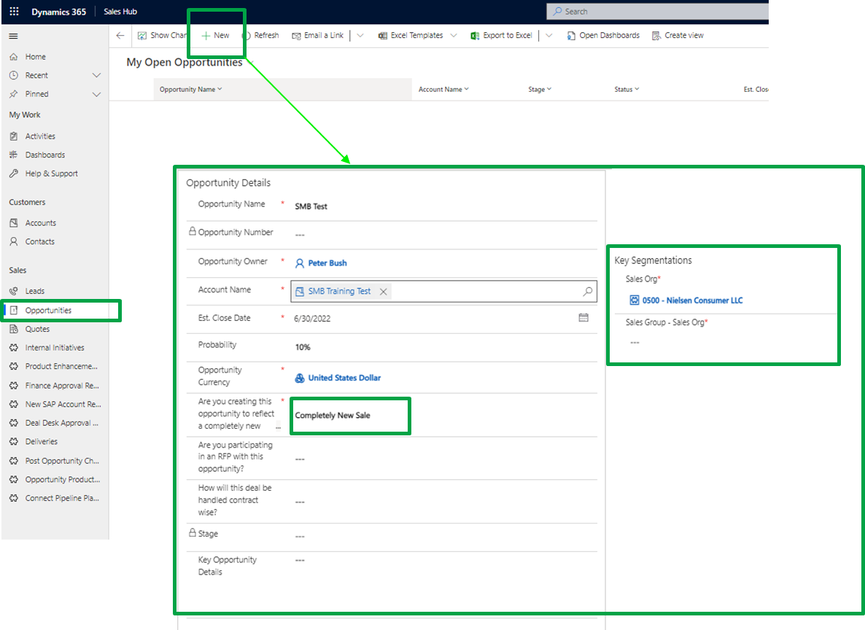

**Q: How do I add other users to my opportunity**

A: After you have created an opportunity, you can add others involved as an Opportunity Team Member from main opportunity page and select “+ Add user”

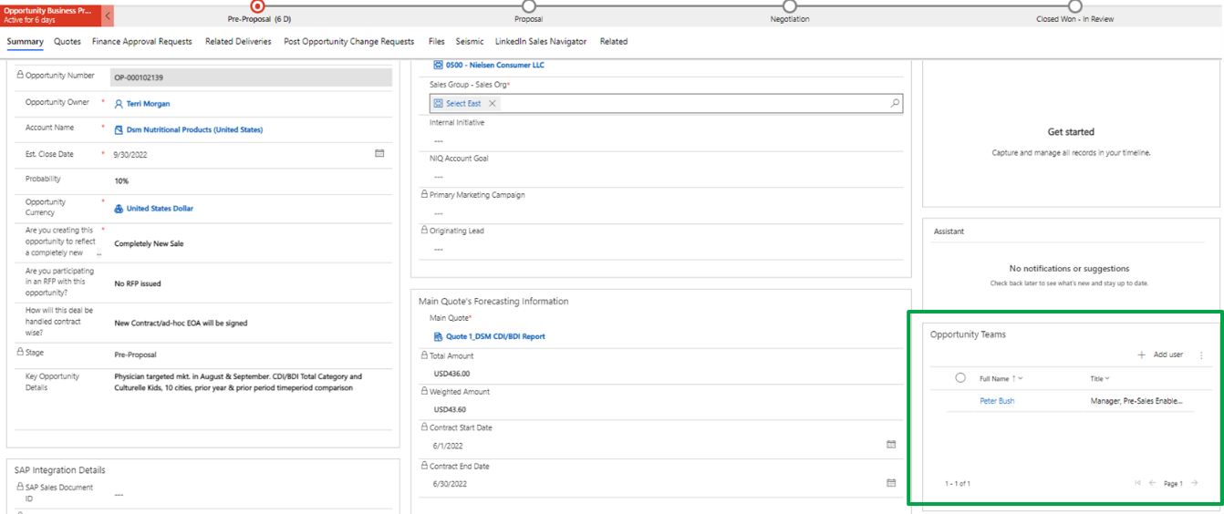

**Q: What are the opportunity stages in Dynamics and how do I manage my opportunity forward**

A: There are 4 stages in Dynamics: Pre-Proposal, Proposal, Negotiation and Closed Won in Review. Refer to required inputs on the opportunity summary tab (signified by asterisks) to progress your opportunity to the next stage

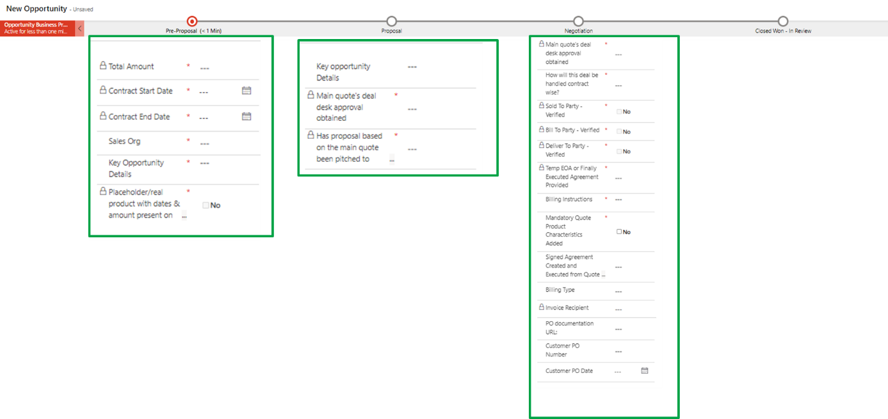

How to Add a Contact to Your Opportunity

***It is important to indicate this data so that at any point in time, you or your team will know who this opportunity is being discussed with***

From Opportunity

Click on Related

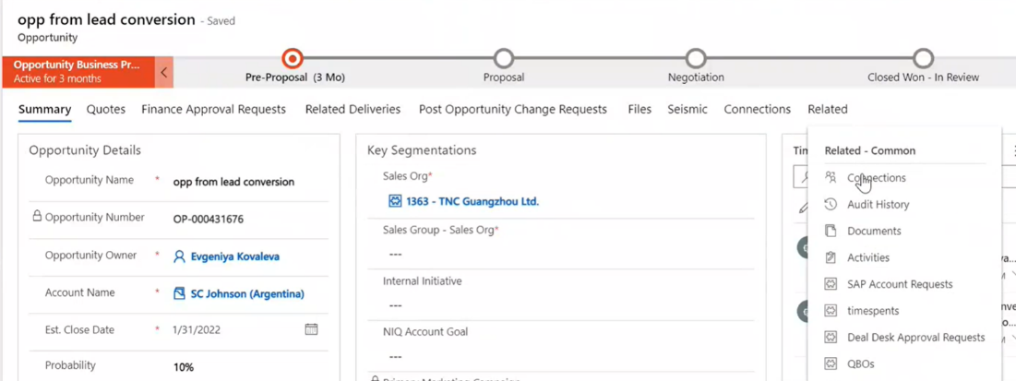

* Choose Connections
* Click on Connect

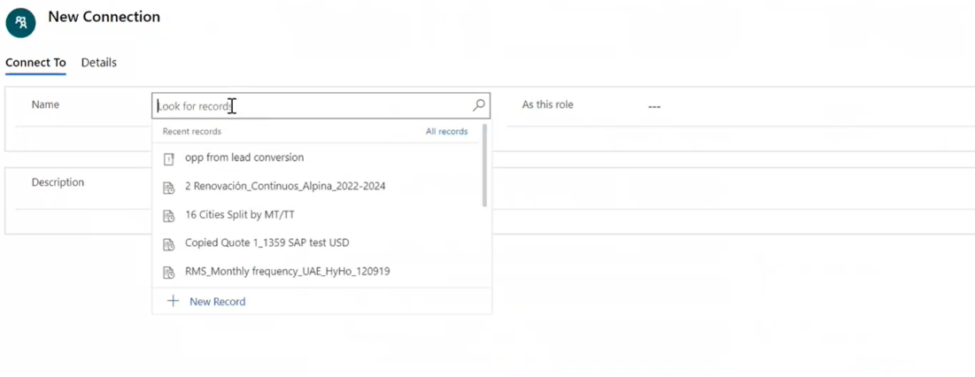

* Click on magnify glass
* Click on Contacts
* Then you can choose only from the contact that is on the list
* **AS this Role**: choose what the contact role is

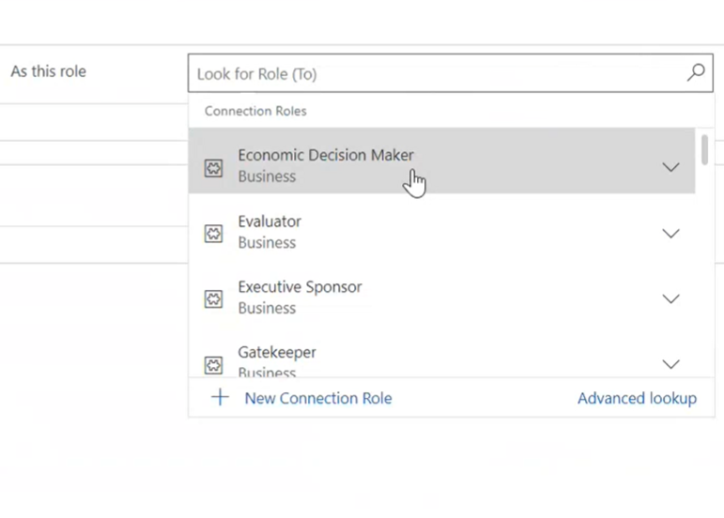

* Description: Can leave any notes or comments in this box
* Save
* Hit the Arrow back to opportunity
* You can now see the contact under Connections

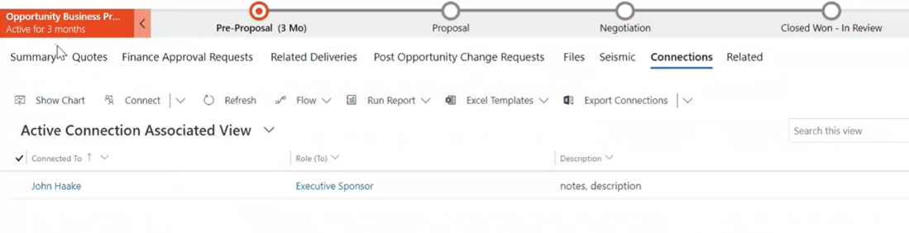

# POC Clients

When you open a new opportunity you have to select the right Sales Org that will indicate if the client is a POC or not. If you have any doubt about if your client is a POC, please check the POC clients list in the [POC Clients (sharepoint.com)](https://nielsenenterprise.sharepoint.com/sites/GENEVAPOCGUIDE/SitePages/POC-Clients.aspx)

**Q**: Not clear on the difference between intercompany and intraPOC?

**A**: Intercompany and intraPOC process are used when you are planning to share revenue with other markets, if the client is POC the right process is intra POC otherwise it’s Intercompany. Be aware that the process is different, that’s why the first step is always to identify if you are in a POC client or not

# Choosing Sold To / Bill To Parties

Key Sap Contract Instructions Section

Typically, these details would be filled out during negotiations stage

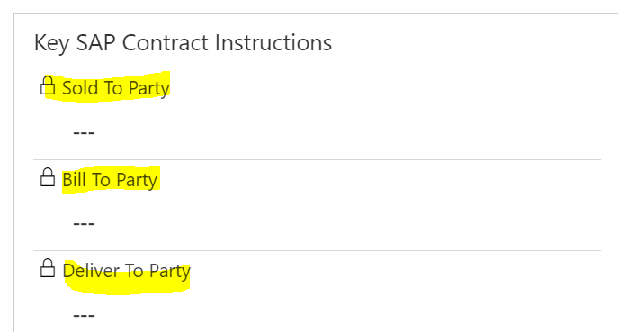

* Sold to party
* Search
* Choose correct option

*\*\*\*for each sap customers you can click on drop down arrows and see more information*

* Click on sold to party you want
* If they are extending to Sales Organization, they will populate
* If they are not, you will see the following

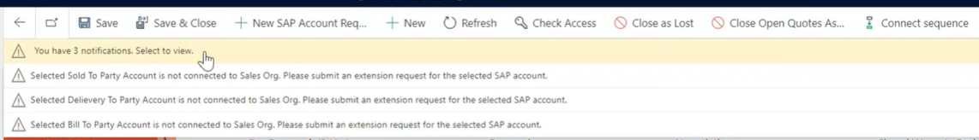

* If it's not extended – then you cannot use
* If you try to save, you will show this showing not verified:

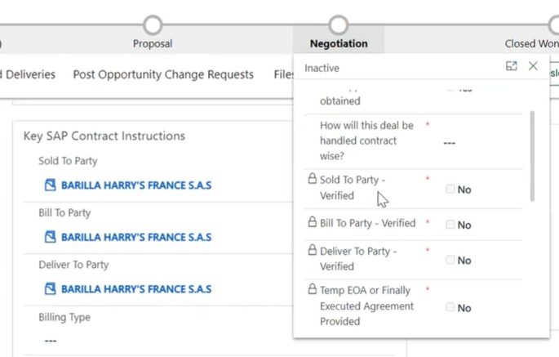

* You can + Raise A SAP request asking to extend to Sales Org
* Once the request to extend it is fulfilled you will be able to proceed
* If the Sold to Party must be that SAP customer, then Raise an extension Notification Request

Otherwise – if you want to see if there are other SAP customers available – click on search icon

* advanced lookup option
* 3 List views pop up
  + Related SAP Accounts – all accounts related
  + NIC Sap Accounts – intercompany revenue shared opportunities
  + Related SAP Accounts extended to Sales Org – will show all SAP accounts available for that org

# Validating Correct Information before Moving to Closed Won in Review

In the negotiation stage once you have received the EoA final or temporary, please check the below information before sending the opportunity to Close Won in review In the quote

1. The products included need to be the same as the ones in the EoA. The client products don’t have the material name; however you need to ensure they are related to the same service and put specific attention on ad-hoc vs periodic material selection. The revenue team will support you if you have doubts about what product to select in quote

2. The revenue schedules and amounts need to be the same as the ones in the EoA

3. The billing schedules and amounts need to be the same as the ones in the EoA

4. Ensure you have populated the SAP mandatory characteristics in the Quote Product Characteristics screen, the mandatory column will say Yes in all of them

5. If the client requests a specific invoice text per product, please add it in the quote Products tab In the opportunity main page

6. You need to complete the Bill To, Sold To and Delivery To information and ensure it is aligned with the EoA information. Watch this video [Choosing Sold-To & Bill To & Deliver To parties.mp4](https://nielsenenterprise.sharepoint.com/sites/MicrosoftDynamics/_layouts/15/stream.aspx?id=%2Fsites%2FMicrosoftDynamics%2FShared%20Documents%2FMS%20Dynamics%20Sales%20and%20Finance%20Video%20Demonstrations%2FChoosing%20Sold%2DTo%20%26%20Bill%20To%20%26%20Deliver%20To%20parties%2Emp4) with a quick explanation of how to ensure you have selected the right name, the video covers how to check quickly:

* + SAP accounts extended to your opportunity’s sales org
  + Internal NIQ accounts for internal billing
  + SAP accounts not extended to your opportunity’s sales org (view used to check if SAP account exists and needs extension)

If your SAP account is not extended to your sales org it means we never invoiced to that client from that Sales Org and you should request the extension to the Sales Org through a SAP Change Request If you don’t find the SAP entity you want to use, it means it doesn’t exist in SAP because we never invoiced to that entity client and you will need to request the creation through a New SAP Account request process

Both processes are managed E2E in MSD and they are the fastest and most efficient way to request to the finance team, please don’t send any external mail to the billing team, since they are instructed to follow the process in MSD. Any communication about those requests will be done through MSD including the final approval Please review in the MSD Sales Training the Sales/Finance Dynamics Transition (5 of 8) lesson with the description of the SAP Change Request and the New SAP Account Request process.

7. If the client has specific billing instructions, you can add them in the Billing Instructions box with any other relevant information for the SAP contract creation

8. If you have agreed with the client a Pre-payment, please ensure you select in the Billing Type “Pre-Bill (Invoice Sent on Signature) and you add the exact dates of the billing in the Billing Instructions

9. Don’t forget to add the link of the EoA or the Temp EoA, following the below instructions:

In the files tab of your Opportunity, upload your document (contract, agreement, PO, etc).

Once the file is uploaded, click the hyperlink of the uploaded file. This will open the file on the NielsenIQ server in a new browser tab.

Copy that URL from the new tab.

Paste that URL into the assigned field (for example: Finally Executed Agreement field). This field is in the Opportunity Summary Tab in the Key SAP Contract Instructions title.

Save

Please don’t send any opportunity to Close Won in Review if you haven’t checked all the above steps

# Recalling and Resubmitting Closed Won in Review Opportunities

**Closed Won in Review** – everything is final, submitted all details and have signed contract

If you need to recall because you forgot to add something or need to make a change, do the following:

At top of screen Recall

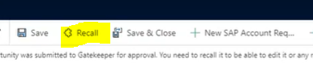

Do you wish to recall? Yes

Once you recall, you can verify by going to Closed Won in Review and checking Approval Status:

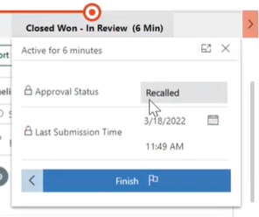

Update the missing details you needed

Once completed, hit Re-Submit For Approval

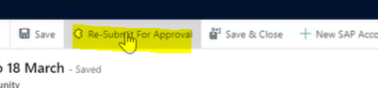

Resubmit for Approval? Yes

*To see the history of the changes, go to Finance Approval Requests and it has them listed*

# Post Opportunity Change Request

Post Opportunity Change Request is the right process to inform the finance team about changes in the opportunity once it has been approved and locked, the cases where you can use a Post Opportunity Change Request are

* Bill-To Client Change
* Invoices changes: invoice recipient change, text messages change
* Final EoA if we submitted the temporary EoA
* PO Details Submission
* Finally executed agreement & Payment Terms submission
* Business Segmentation change (internal initiatives, NIQ account goal..) approved automatically no finance involvement

Once you are in the PPCR screen select the change you want to process and include all the mandatory information, the billing team will be informed, they will review the request and they will approve or reject it. You can check the status of your request in MSD, also, you will get an email notification once your request has been approved or rejected.

It's very important you process the Post Opportunity Change Request as soon as you know about the change to ensure the client doesn’t receive the old information after communicating a change Please review in the MSD Sales Training the Sales/Finance Dynamics Transition (6 of 8) the third lesson “Post Opportunity Change request”, where you can find more information and a demo video.

1. Opportunity must be in Closed-Won Approved to submit a POCR
2. Choose + Raise Change Request

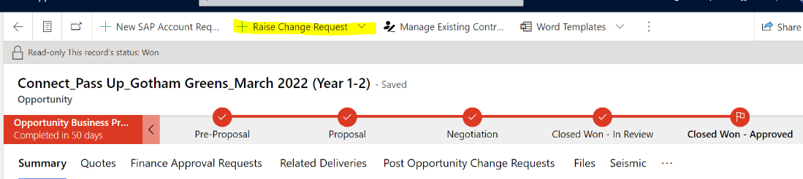

1. Choose which option you are submitting for

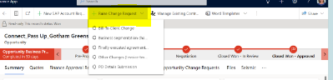

1. Complete the * details in the Quick Create: Post Opportunity Change Request

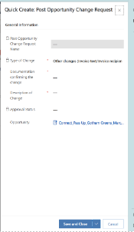

1. Hit Save and Close

# Quotes General

**Q: How to create a new quote**

A: This is where you will input product and pricing info. A quote will need to be created after you create an opportunity. Follow the steps below to create a new quote or configure the pricing information:

•Hover over the quotes section of the opportunity and select the quote under “all quotes”

•If one does not automatically appear, click on new quote

•Make sure quote you are proposing to client is selected as the “Main quote”

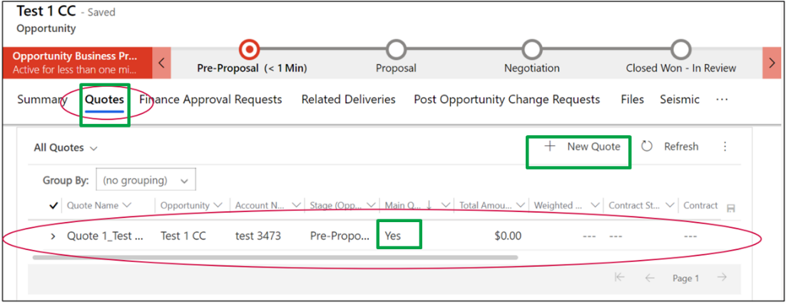

•Once in the quote, hit “configure” located in the top header of dynamics to open Experlogix

•Choose Select Products when the new window opens and proceed to build quote with automated rate card or manual entry (see below)

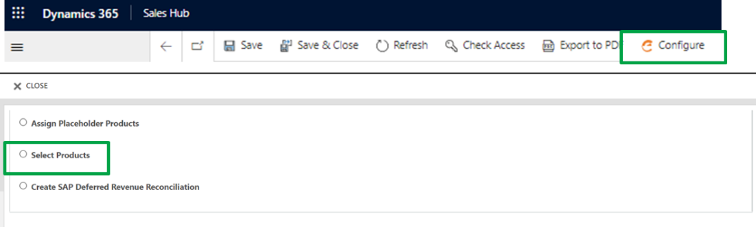

**Q: How to Build Quote with Automated Rate Card US case**

A: Use this function for ad hoc and Ongoing opportunities of a **product in automated dynamics rate card such as RMS & KAD.** List of all solutions in automated rate card can be found [here](https://nielsenenterprise.sharepoint.com/:w:/r/sites/USConnectPricing/_layouts/15/Doc.aspx?sourcedoc=%7B995384c1-8aaf-4186-b91b-235899f96e6d%7D&action=view&wdAccPdf=0&wdEmbedFS=1)

1. Once in Experlogix, select start & end dates from “manage defaults” tab. You can also adjust billing terms here

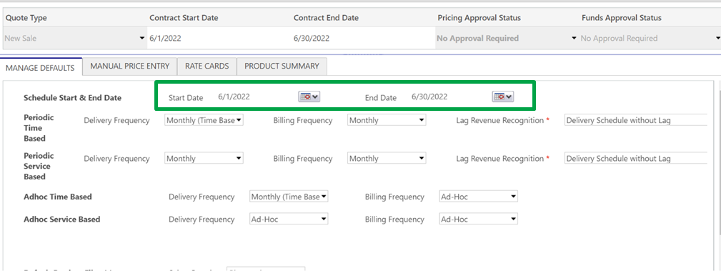

1. Move to “Rate Cards” tab and select US-RMS & KAD Ad Hoc or US-RMS & KAD ongoing and click on the + in right corner

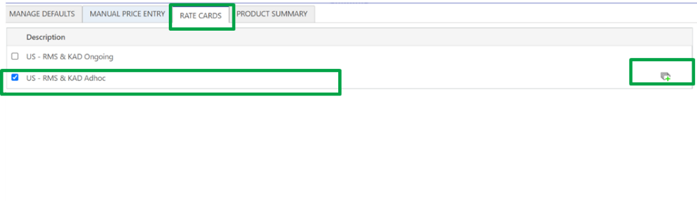

1. Once the new window opens, select the following:
   1. 1 year term
   2. Select AOD or Connect/Discover
   3. Select “syndicated” as data base type.
   4. Give the data scope a name
   5. Hit configure
2. Another window will open, where you will select additional inputs:
   1. Delivery frequency (monthly, weekly, one time, quarterly)
   2. Level of detail (standard- upc level; Brand; Category; Department)

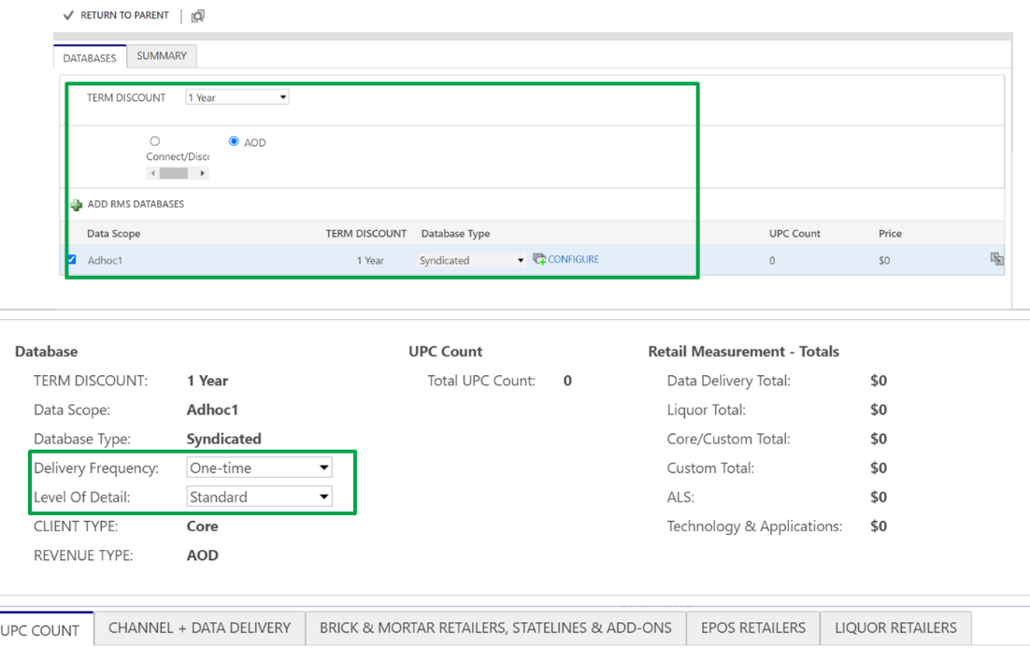

1. Input the required specs of opportunity including:
   1. •UPC Count
      1. Refer to [RPM adhoc form](https://nielsenenterprise.sharepoint.com/:x:/r/sites/USConnectPricing/_layouts/15/Doc.aspx?sourcedoc=%7BA46228BB-D8F1-43D1-B8A6-4F2B9DF6599A%7D&file=Retail%20Intelligence%20(RPM)%20Adhoc%20Pricing%20Request%20Form.xlsx&action=default&mobileredirect=true) for accurate # UPCs if needed
   2. Channel & Data Delivery
      1. Select years of history (3 yrs is standard; or 4/5 yrs for upcharge)
      2. RMS Database Specs
         1. CHANNELS/SMMs/REGIONS/DIVISIONS
            1. If less than 10, select number of SMMS within the “input”
         2. NPI is also inputed here
   3. Brick & Mortar Retailers, Statelines & Add ons
      1. Select standard and premium retailers
   4. EPOS Retailers
   5. Liquor Retailers
2. Once all inputs are done, hit return to parent to view summary
3. Use the product summary tab to review inputs, changes, schedules, and approval requirements
   1. You can adjust discounts and markup here
      1. Add a discount percent under “discount amount”, it will apply to all lines in the quote that are discountable. If you add line-by-line, under Initial Discount you can discount any line.
      2. A price can be marked up with a negative discount #

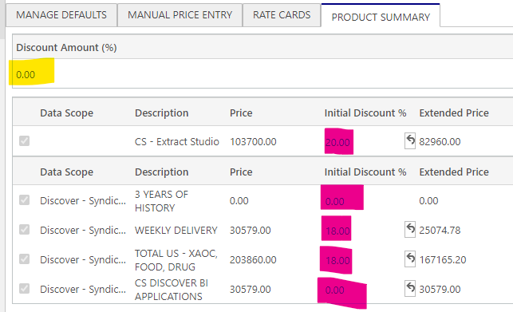

1. Once things look good, hit save and close to return to opportunity

**Q: How to Build Quote with Manual Price Entry**

A: Use this function for opportunities of a product not yet in automated dynamics rate card, or for product priced separately by specialty sales (panel, omni, tdlinx, spectra, etc) or Byzzer team.

For any opp that the pricing team quotes out (such as those not in automated rate card) share the pricing opp # with pricing analyst and ask them to input book price. Pricing team will manually add correct $ amount directly into your quote and you do not need to do the manual price entry. If product is going to priced out by pricing team, make sure to add pricing analyst to your opportunity

1. Once in experlogix, select start & end dates from “manage defaults” tab. You can also adjust billing terms here
2. Move to the “Manual Price Entry” tab, select “+ add product”
3. Select the required products by scrolling through the menu or by searching by product description, product hierarchy (RMS, CPS, AAC etc)
4. Hit Save
5. Modify unit prices
6. Use the product summary tab to review inputs, changes, schedules, and requirements. Hit Save & Close to return to opportunity

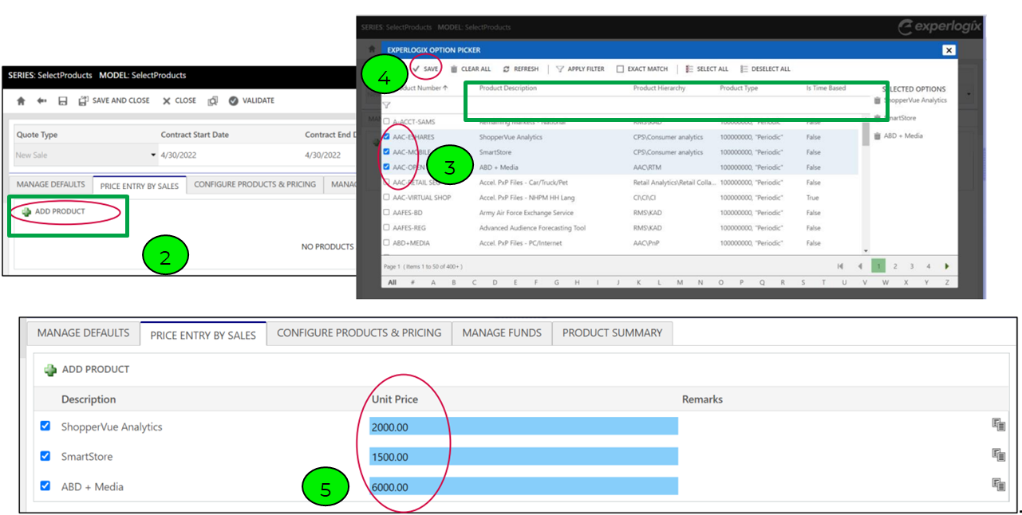

**Q: Can more than one person configure a quote at once?**

A: No, only one person can edit at once. If a quote is being edited by another person, you will see a red lock icon on the top left of the configuration screen. Hover over the red lock icon to see who is currently editing the quote.

**Q: I am getting an error that my quote will not save. How do I fix this?**

A: First, check if the content in the remarks field is very long. MSD currently has a limit of 20 chars on that field, including spaces. There is a future upgrade to increase that limit. For now, shorten the text in the remarks field and your quote should save. If it still does not save, please raise a help & support request.

**Q: One service in my proposal will not be ready until the sixth month of the contract. How do I reflect this in MSD?**

A: Change the start date for that line of the quote.

# MSD Quotes & Term Length

**Microsoft Dynamics (MSD) & Term**

First, know that by the time an opportunity is closed/won, the total value of the opportunity should reflect the cumulative value of the contract. For example, a 2-year term with a $1,500 annual price will have a total value of $3,000 in MSD. The revenue scheduling feature will ensure the opportunity is forecast correctly, i.e., it will spread the revenue across the term.

Some examples of term lengths you may see on various opportunities:

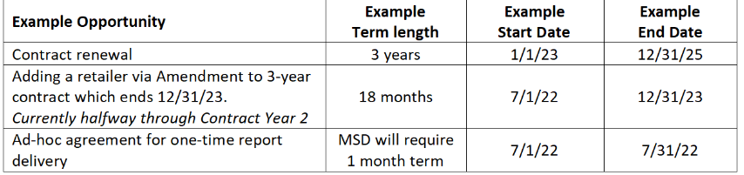

Notes:

* Cost of living adjustment (COLA) are excluded from the total value of the contract, per MSD processes.
* The rest of this document is focused on continuous services, which are delivered multiple times per year and billed on a monthly/quarterly/etc. cadence. One-time deliveries such as ad-hoc reports generally do not need to worry about term length beyond ensuring an accurate start date is chosen.
* Start and End dates must be entered as the 1st of the month through the last day of the month.

**Term & Quotes in MSD (Experlogix)**

Automated rate cards will provide you with the cumulative price over the term. For example, if the rate card price is $1,500 annually and the start & end date are 24-months apart, the automated rate card will show $3,000 as the (cumulative) price. Using the same rate card example, if the start date is 7/1/22 and the end date is 12/31/23, the automated rate card will provide a (cumulative) price of $2,250 = $1,500 per year / 12 months per year * 18 months term = $125 per month * 18 months. In both cases, the revenue schedule will show $125 per month.

When using Manual Price Entry, you must ensure that the price matches the term you have entered. Again, using an example of a service that is $1,500 annually, manual price entry should be $1,500 if the term entered is 12 months and $2,250 if the term entered is 18 months.

**Best Practice: Start with 12-month term, adjust by Negotiating stage**

Generally, US sales teams will include the annualized price in client proposals. To support this practice, when the US Deal Desk team is asked to provide incremental pricing, we will initially enter it into MSD with a 12-month term. We also recommend the sales team do the same when they are utilizing automated rate cards. An opportunity could reflect a 12-month term in both Pre-Proposal and Proposal Stage.

For revenue forecasting purposes, it is important to have an accurate start date even if the term length is not fully known yet. When US Deal Desk team enters an incremental price, we will use the first day of the following month as the start date unless we are given other information; the opportunity owner should update that start date as needed.

Once the term is established, the opportunity owner should then adjust the opportunity to reflect the accurate term length. This should be done no later than the Negotiation stage, before the contract or amendment is drafted. This requires reconfiguring the quote to change the start & end dates and multiplying any manual price entry by the full term. Calculator helper file here. US Deal Desk team can help with this as needed.

Of course, if it is easier for AD/Sales on a given opportunity to utilize the accurate term from the Pre-Proposal stage, US Deal Desk will support this

**Impact on MSD Deal Desk Approvals**

For more information on when MSD requires Deal Desk approval, see this [file](https://nielsenenterprise.sharepoint.com/:p:/r/sites/USConnectPricing/_layouts/15/Doc.aspx?sourcedoc=%7BFDC5CF14-B9F7-4FCE-9E18-44DA3EFB0312%7D&file=Updated%20US%20Discount%20Policy%20%26%20Approval%20flow.pptx&action=edit&mobileredirect=true).

At this time, MSD requires Deal Desk approval to be redocumented anytime a quote is changed. This includes if the start/end dates are moved, or the term length is changed. If a quote was approved with a 12-month term and reapproval is required once the quote is updated to the final confirmed term length, US Deal Desk will make every effort to quickly execute the reapproval. We are also happy to provide the initial approval based on a term that is different than 12 months, if easier for AD & Sales teams.

**Term Discount & Term Length in MSD**

While term discount and term length are clearly related, within MSD term discount is selected independently from term length. Term discount is selected when configuring a rate card or is manually included in manual price entry. If the proposal will be for a 3-year term, but the sales team need to generate an annual price, they can configure the quote for a 12-month term and pick a 3-year term discount. The quote must be updated later to reflect the full 3-year term.

# Billing

**Q: Do invoice recipients and email addresses need to be completed?**

A: Yes, for every opportunity, unless it is an amendment and its part of the contract billing

# Purchase Orders

If your client is required to purchase order, the billing team will not approve your opportunity until the PO is released and attached to the opportunity in MSD. This means until a PO is attached, your opportunity will stay in a Closed Won in Review status and no delivery objects will be created until we have the PO.

Please check the following before adding the PO

1. The PO amount should be the same as the total amount of the product/s that it’s related to or to the total opportunity amount

2. POs lower than the total amount will be rejected and you will need to request the right one to the client, higher POs will be processed since the invoice will reflect just the sign-off contracted services

# Funds

Some clients are eligible for specific funds, if you want to use the funds, you will need to get the approval to use funds outside MSD.

This approval needs to be attached to your opportunity in MSD (files section) and you should include in the Billing Instructions the products covered by the Funds to be processed manually by the Finance team.

# Evidence of Delivery (EOD)

Evidence of Delivery is needed in the International markets for all Ad-hoc products to recognize the revenue. When the opportunity is close won approved, a Delivery entity will be created for each ad-hoc delivery included into the contract. You should use created deliveries to inform Finance of the changes in the planned delivery dates or to submit EOD to them so that they unblock the revenue in SAP. This is the only process to inform the finance team about an EoD or a change in the delivery date.

You can check all your opportunities pending on a Delivery using the Deliveries object in the left side menu and selecting My Active Deliveries

**Q: How do I EOD if there is not a delivery created?**

A: Only Finance can create a delivery. If an opportunity in Salesforce didn't have a related Delivery, it will not be present in MS Dynamics either. In order to submit EOD for such cases you need to follow these steps:

* Upload the EOD file to an opportunity
* Get URL link for it
* Raise a Post Opportunity change request with "Other changes" type and provide EOD URL link there
* Click save which will submit this request to Finance for action

**Q: How do I submit EOD in MSD?**

Your opportunity must be “Closed Won – Approval". If you have already delivered a product or service by the time, you are closing it in Dynamics, ensure to upload proof of EOD to the files section as a best practice

Attach evidence of delivery to “Files” tab in Dynamics and copy the EOD URL from the Path field

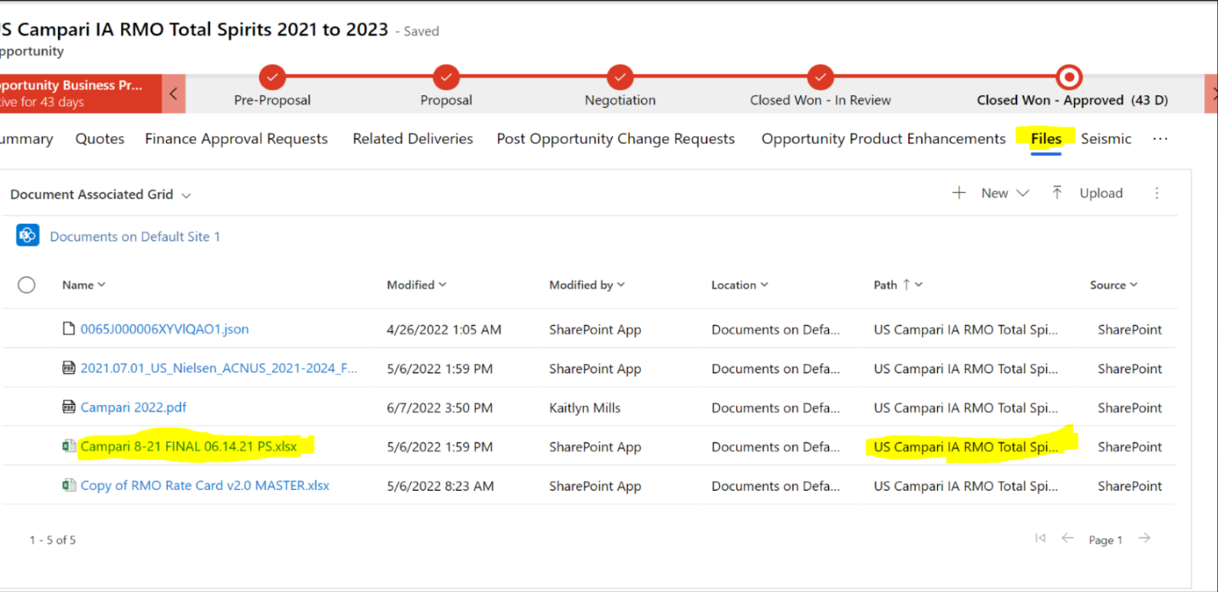  
Click on “*Related Deliveries*”

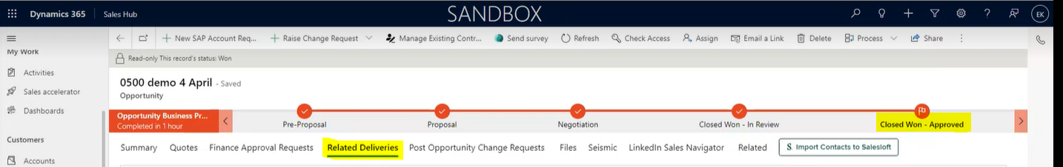  
Click on relevant “entity” or delivery option to EOD

* 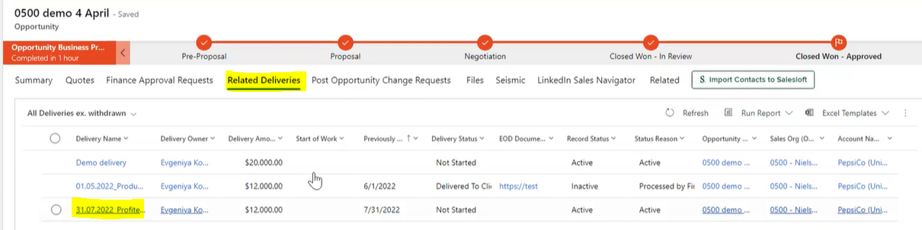  
  Once in delivery entity; Scroll down and paste EOD URL in “EOD Documentation URL” field
* Change “Forecasted Delivery Date” to the actual date of delivery
* Change “Delivery status” to Delivered to Client
* Hit “Save” which will automatically create a Finance approval request to approve delivery

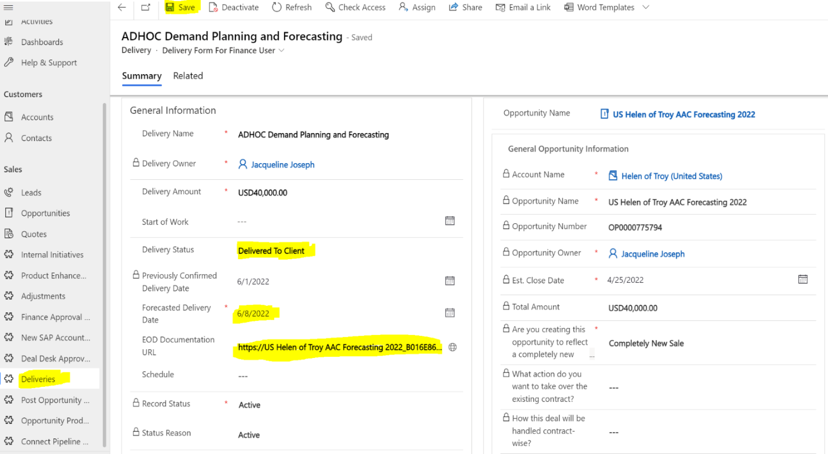  
5. Once delivery has been approved by Finance and recognized in SAP, the delivery becomes” inactive” and locked

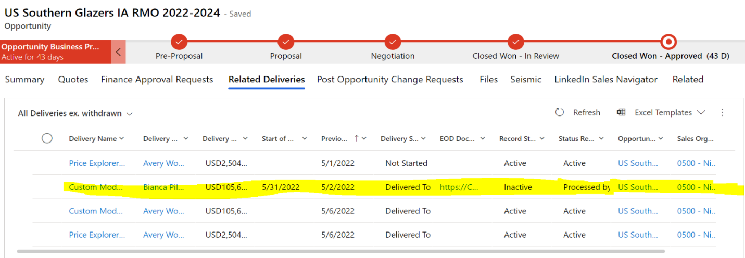  
**Mass EOD in MSD**

1. Go to the deliveries view in MSD

a. Click on deliveries on the left-hand side

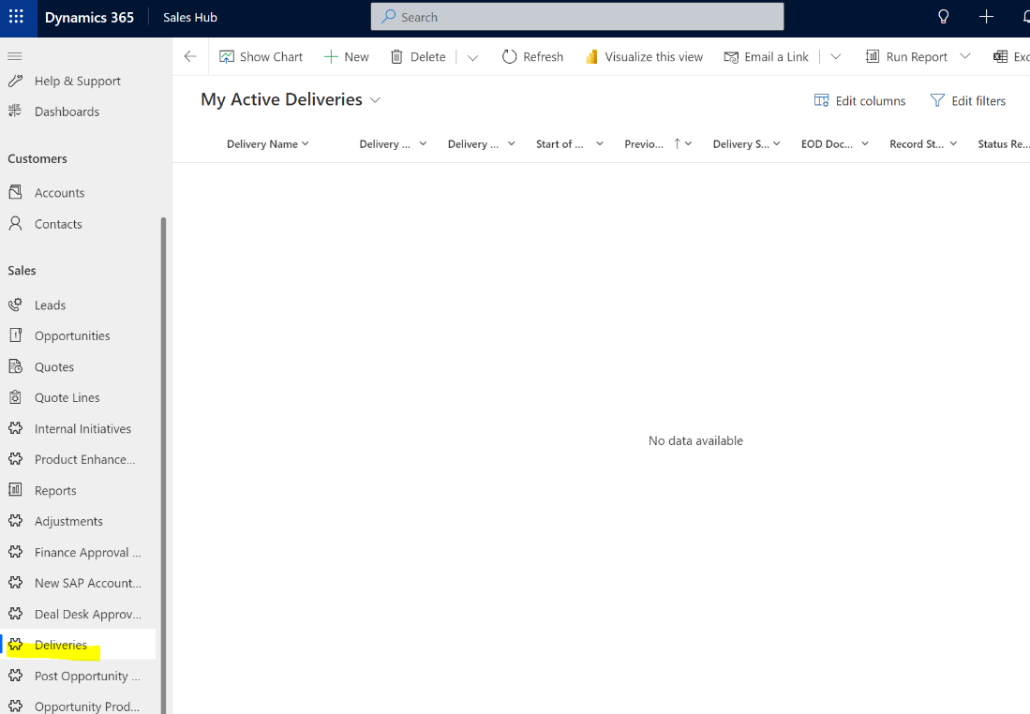

2. Update your settings to show the maximum number of lines

a. Click Settings / Personalized Settings

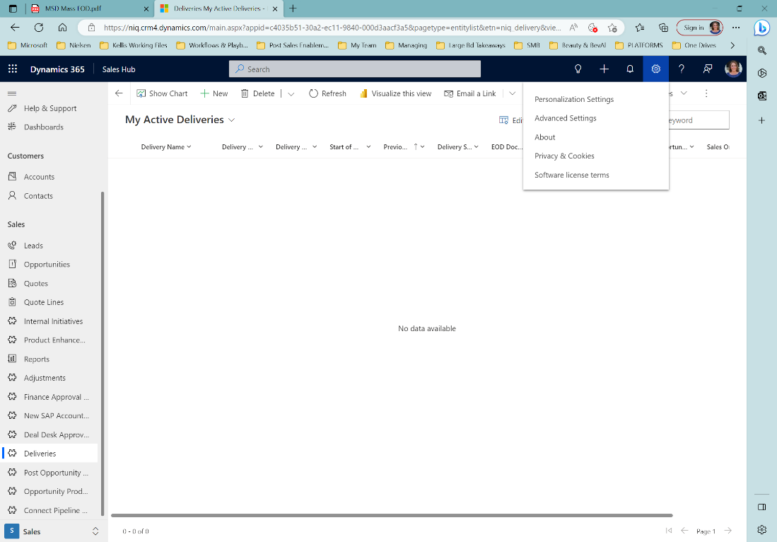

b. Select 250 Records per page and click OK

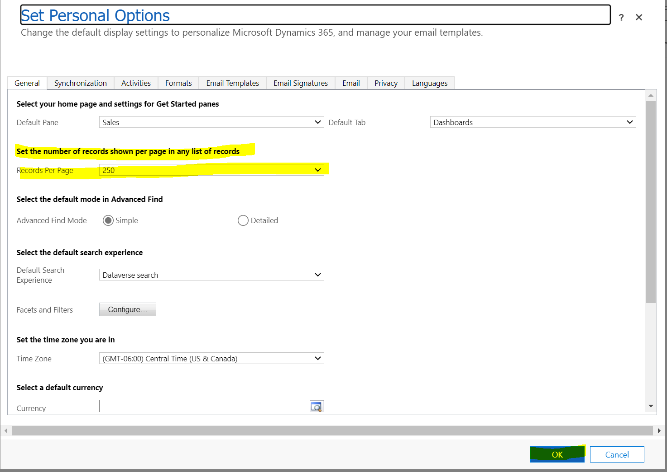

3. If you are not tagged as the delivery owner, you may need to change the view as it defaults to My Active Deliveries. You can click the dropdown and select All Deliveries

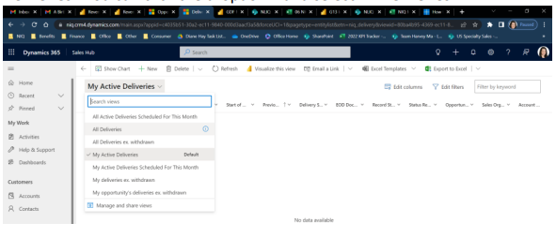

4. To isolate the deliveries related to one opportunity, enter the opportunity name in the Filter by Keyword search bar and click enter to filter

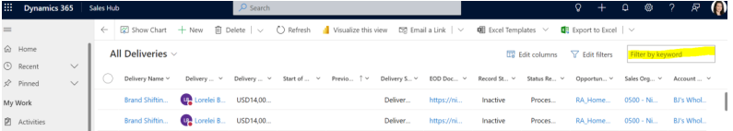

5. Click the circle at the top of the page to select all delivery objects for that opportunity. Unselect any items that should not be EOD’d (e.g., services that have not started, annual deliveries, etc.)

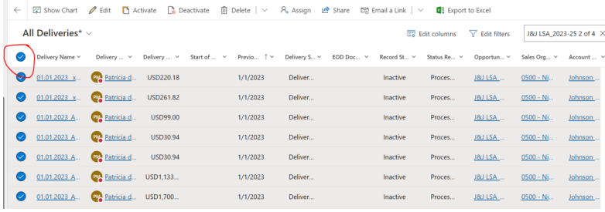

6. Click the Edit button at the top of the page

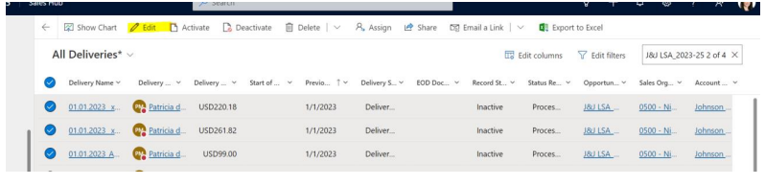

7. A new window will pop up. Select to update the delivery status to “delivered to client” and click Save to implement. It may take some time to update all the delivery objects depending on how many you have

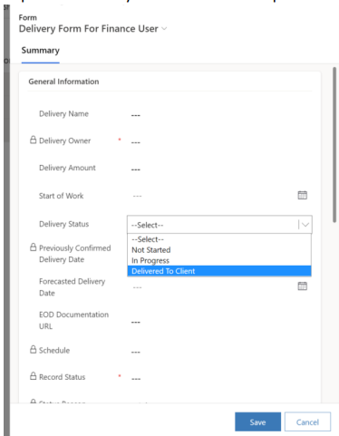

8. The delivery status will now show as Delivered for the selected delivery objects

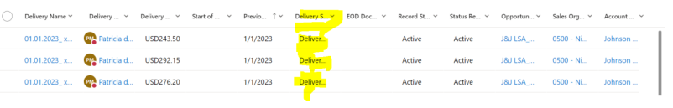

9. If you have more than 250 deliveries, you will need to scroll to other pages to EOD the remainder of the delivery

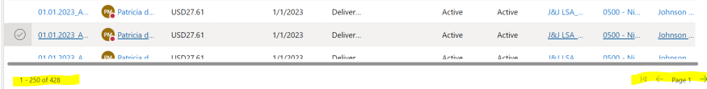

# Deliveries

**Q: Who can create deliveries in (that are not autogenerated)**

A: Only Finance can create delivery objects

# Price Changed on Sold in Ad Hoc Migrated from SF

**Q: An Adhoc Agreement was sold in and migrated from SF but the price changed**

*\*\*any opportunity migrated from SF it is not linked to Experlogic - so if you were to add a product now, it would double - so you need to move the Quote to Close Lost and Create a new Quote if changing the price:*

* In this case - since changing the pricing you must move Quote to close lost
* Go back to opportunity - move it back to proposal
  + click on Proposal Stage - if moving from closed one review - see the finish button - do not Click on that!!!! when you click on it, it ends the process for the opportunity - so need to reactivate it now;
  + go back to proposal stage
  + set active - moving opportunity back to proposal stage
  + Should show a closed lost option on opportunity main page
  + Close Open Quotes as Lost
  + OK
  + Refresh
* Go to new quote
  + Rename the quote so you know what it is
    - *approved or not approved - that is for deal desk - will go away if no deal needed;*
* Go back to opportunity
  + Go to quotes
  + Click in new quote - needs to be changed to main quote -
    - if cannot - go to summary
    - go to main quote
    - delete what is there
    - go to spy glass
    - choose new quote
    - save
* go back to quote
  + make sure new quote is main
  + go to summary - - this is how you look to see what main quote is to verify its correct;
* go to Quote related
  + Configure - will open experlogix
  + select product
  + enter billing information
  + change dates if needed and update billing if needed;
* manual price enter - this is where you select your product; *pricing team not giving rev codes anymore* 
  + Start typing to search and choose the right product code
  + save once have product code
  + enter the price
  + now in product summary tab - review it and make sure correct -
    - if click green + sign and make sure everything looks right
    - save and close
* Go back to opportunity - summary - make sure all correct
  + quote products
  + if need any quote product char - if any changes;
  + if anything is mandatory it will say yes and you need to fill out
  + save and close
  + takes back to opportunity
* Move back to Closed won
  + A note will pop up that it was submitted to gatekeeper
  + wait for them to approve before EOD

Amendments

**MSD Training for Amendments/Renewals can be found in session 7 of the** [**[Sales/Finance MSD training.](https://theniels5.plateau.com/learning/user/deeplink.do?OWASP_CSRFTOKEN=O0AP-O4MF-SWX3-6D8S-57KU-CNHO-R9A9-WQ24&linkId=PROGRAM_DETAILS&fromSF=Y&programID=500-SFDT101-MSD)**](https://theniels5.plateau.com/learning/user/learning/program/viewProgramDetails.do?OWASP_CSRFTOKEN=WBB0-SL32-MG1Q-4INX-MMVO-P9KJ-PR31-7WGX&fromSF=Y&programID=500-SFDC100-MSD&menuGroup=Learning&menuItem=Cur&fromDeepLink=true&hideProgramDetailsBackLink=true) **Refresh your knowledge there first. The Deal Desk can help with questions and inputs. Video demonstrating how to fill out Revenue Walk Input will be provided in "Renew Expiring contract" section.**

**Revenue Walk Input:**

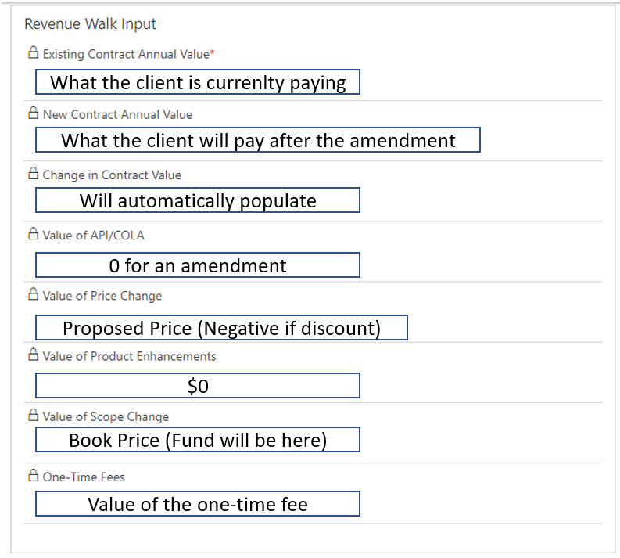

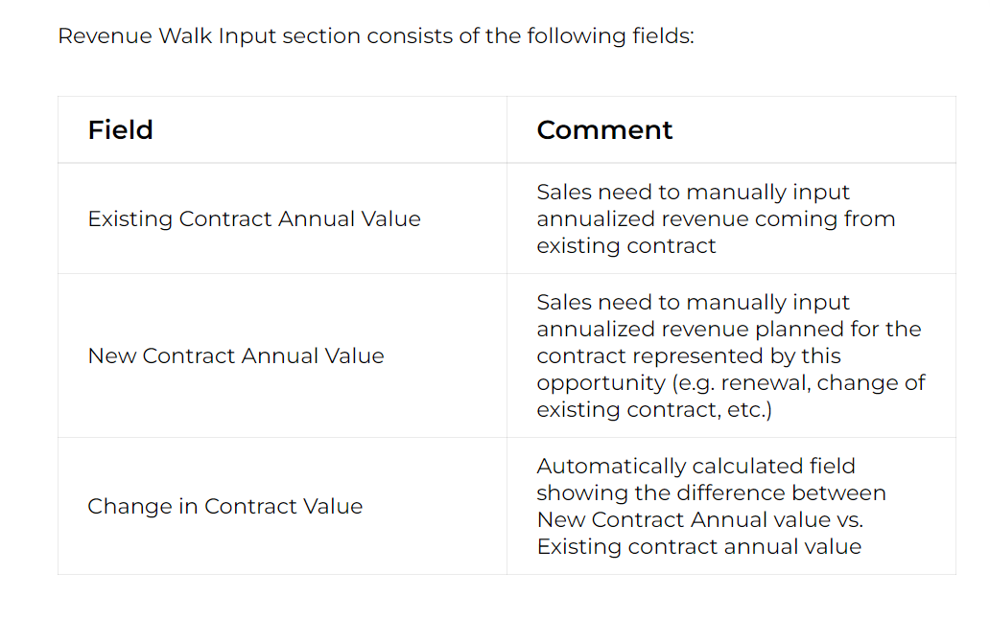

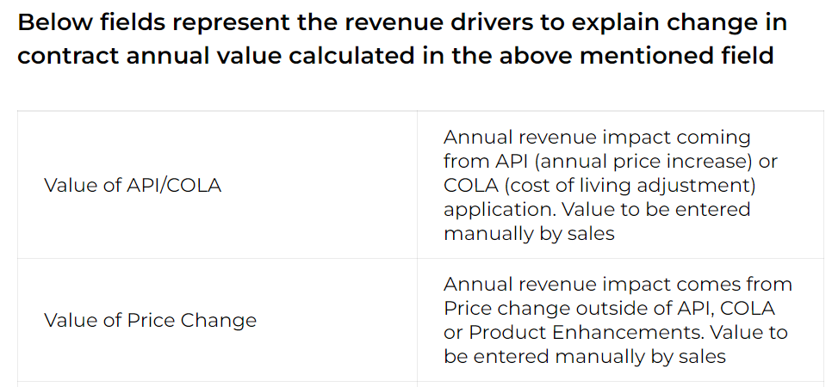

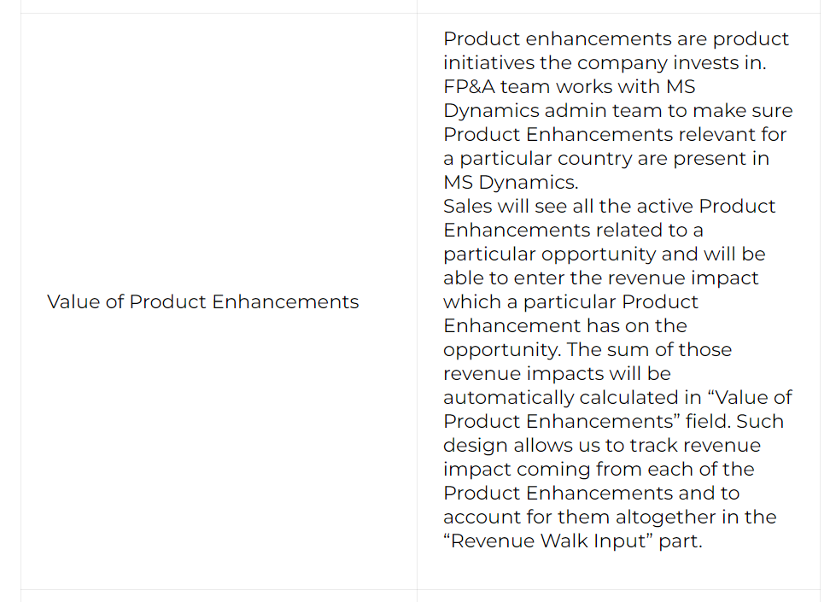

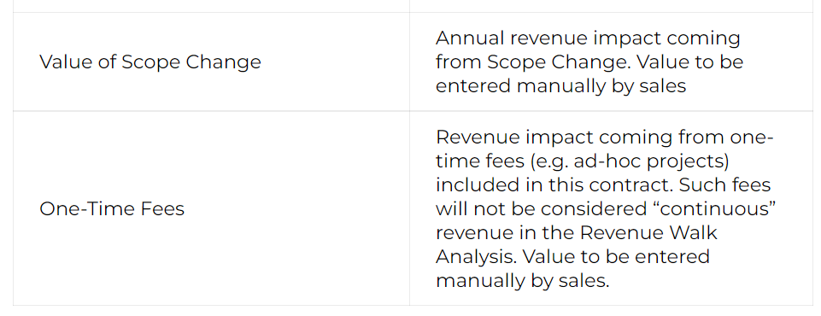

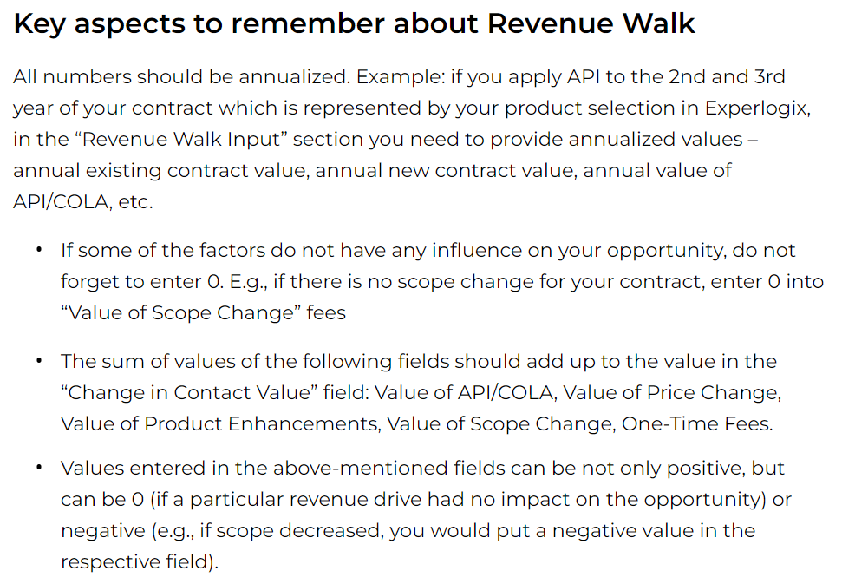

Manage Existing Contract – Revising Scope

***The client has a current contract today that is managed in SAP. Client wants to change the scope/markets.***

# **Change scope & conditions before contract expiration**

* Sometimes changes may be needed to an already signed contract before it expires. This can happen when a client wants to increase/decrease contract scope, change any important conditions there, etc. To represent this change sales will use an opportunity with “existing contract action” = change scope & conditions before contract expiration. Sales should create such an opportunity proactively to anticipate a potential change and account for it in pipeline and forecast.
* If a won opportunity representing current contract exists in MS Dynamics, the opportunity representing potential scope & conditions changes should be created via “existing contract management” button on the existing won opportunity. If such opportunity does not exist, the opportunity representing renewal should be created from scratch.
* As a reminder, the “change scope & conditions before contract expiration” opportunity should represent the planned contract scope in full, not just the difference vs. current contract. This full scope represented by quote and quote products will be marked as “revenue forecast excluded” and will not be considered in pipeline management and forecasting in order not to duplicate with existing revenue already present in SAP. However, the difference between existing contract and its anticipated changed version should be accounted for in pipeline management and forecasting. The difference should be represented by “SAP deferred revenue reconciliation” line(s) added as per the instructions shared in one of the respective previous lesson.
* Deal desk approval will be required for “change scope & conditions before contract expiration” opportunity if its scope is not in line with standard rate cards.

**See** [**MSD Training**](https://nam02.safelinks.protection.outlook.com/?url=https://performancemanager4.successfactors.com/sf/learning?destUrl%3Dhttps%253a%252f%252ftheniels5.plateau.com%252flearning%252fuser%252fdeeplink_redirect.jsp%253flinkId%253dPROGRAM_DETAILS%2526programID%253d500-SFDC100-MSD%2526fromSF%253dY%26company%3Dtheniels01P2&data=05%7c01%7cNatalia.Pina%40nielseniq.com%7c248a78e4dade40d0ab7608db06207ae4%7c6ac7a1f45fb14153bb4f12d2020a1f7d%7c0%7c0%7c638110510324445845%7cUnknown%7cTWFpbGZsb3d8eyJWIjoiMC4wLjAwMDAiLCJQIjoiV2luMzIiLCJBTiI6Ik1haWwiLCJXVCI6Mn0%3D%7c3000%7c%7c%7c&sdata=u1Zw9C/dGQxVcY71UbP9O2plnC934YebawxfOiCKNCo%3D&reserved=0)**, section 7, ‘change existing contract scope’ for a 22 minute video walk through**

Find the Contract Renewal Opportunity in Dynamics that is for the original LSA

Click on Manage Existing Contract

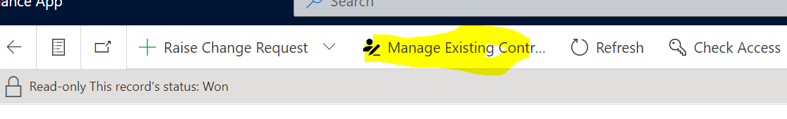

This will open a new Opportunity - Complete the Details

* Opportunity Name

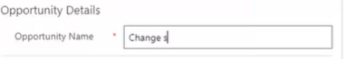

* Estimated Close Date

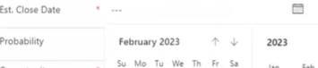

* Are you creating this Opportunity to reflect a completely new? **Existing Contract Management**

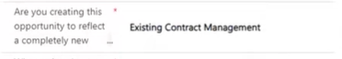

* What Action do you want to take over the existing contract? Change scope and conditions

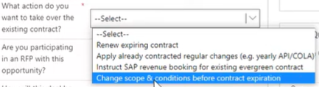

* Key Segmentations – these came over from original opportunity – you just need to verify it

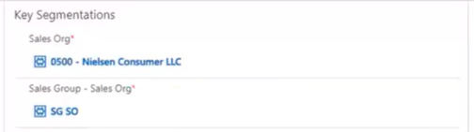

* Existing Contract Reference – this is on here because we are changing original contract, so we need to provide revenue walk for what drives the change
* For now, just enter the Existing Contract Annual Value (this needs to be entered by sales)

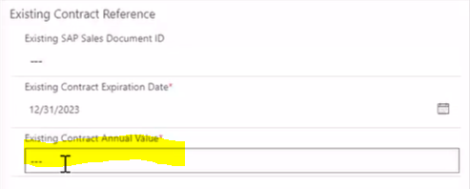

* Save
* After you save, you need to make sure Main Quote from Opportunity appears automatically (it could take a couple minutes – you need to refresh your page, sometimes a couple times) before it appears

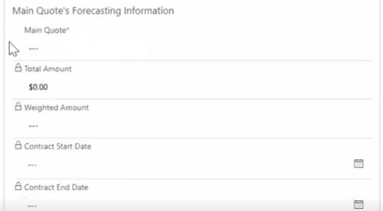

* Click on the Quote

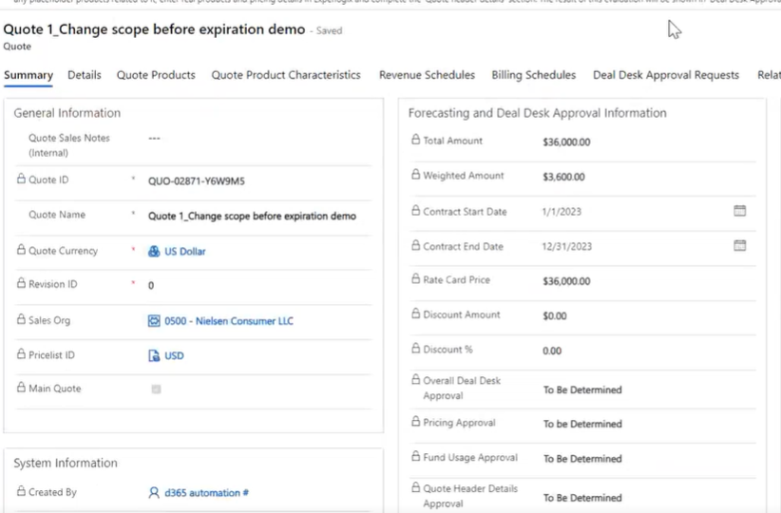

* Next need to add the new product to the Quote

***Golden Rule: Quote always presents full contract scope, never the difference between the original contract and the new contract***

Open Quote

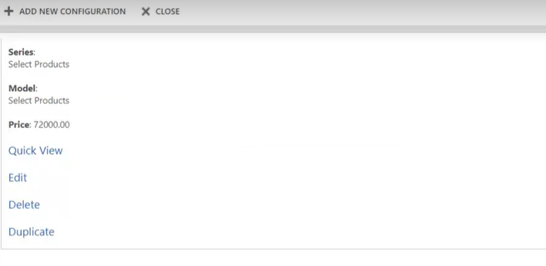

* Click Edit
* Price Entry by Sales

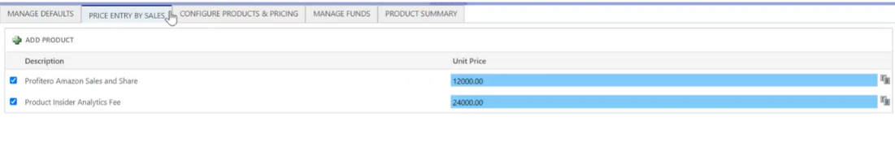

* + Product
* Add new product
* Need to configure the new price – go back to Price Entry by Sales
* Enter Price
* Product Summary - +
* Need to update dates accordingly
* Save and Close

**How do you avoid double counting?**

If the current contract is already in SAP and the new contract is in Dynamics

Go to revenue schedules

* Click on carrot to expand

You will see Revenue Forecasted Excluded

System knows to not take product information into pipeline – because it's in SAP so it's not double counted

But how do we make sure new revenue is included in forecast and Pipeline?

* Must go to Configure at Top (Experlogix)
* And from presented options
* Choose Create SAP Deferred Revenue Reconciliation

This will create a placeholder product

Capture Difference between old and new contract and the difference will be taken into account for pipeline and forecast information

* Choose Dates for new Product Contract
* Choose Delivery Frequency
* +Add New SAP Deferred Revenue Reconciliation Placeholder
* Select Brand: Choose Option
* Sub Brand: Choose Option
* Reconciliation Amount: Enter amount of new contract
* Save and Close
* Under Revenue Schedules you should see another product created – SAP Deferred Revenue Reconciliation
* Refresh as needed to get revenue schedule to update – you should see the revenue you added as Revenue

*Need to make sure the Full contract Scope is accounted for in Dynamics now – to manage previous opportunity – this is* ***VERY*** *important with the latest opportunity instead of trying to compile from several opportunities*;

The first step is to make sure revenue forecasting is correct

* Go back to Opportunity
* Under Pre-Proposal complete the details:
  + Key Opportunity Details
  + Are you Participating in and RFP with this opportunity?
* Next Stage
* In Proposal
* Main Quotes Deal Desk Obtained:
* If says no, go back and quote and see status

**Quote Header Details: If says To Be Determined:**

* Troubleshoot: Go to Number of FTEs and enter any value
* Save
* It should say approval required
* Go back and change to 0 if not including any FTEs
* Save

Quote Header Details should update then and say ***No Approval Required***

* Go back to Opportunity
* Proposal
* Make sure the Main Quote is the quote approved by client
* Has Proposal Based on the main Quote been pitched to Client? YES
* Moving to the next Stage

**Negotiation Stage:**

* How will this deal be handled Contract Wise:
  + New Contract/Ad HOC EOA will be Signed
  + Existing Contract will be amended

**Need to add Remaining Details:**

* Has Revenue Walk Analysis been completed?
* Final Executed Agreement
* Mandatory Product Characteristics
* Any billing details necessary if applicable
* Save

**Revenue Walk Input**:

* **Existing Contract Annual Value**: should already be completed from earlier steps
* New Contract Annual Value: Enter
* Save
* Change in Contract Value Auto Calculates

**Need to complete what impacted this Change in Contract Value:**

* Value of API/COLA
* Value of Price Change
* Value of Product Enhancement
* Value of Scope Change:
* One Time Fees

This is what is impacting Change in Contract Value because we are simply changing the scope of current contract

* Enter the Change in Contract Value in Value of Scope Changes
* One Time Fees: $0 if not impacted

Once completed, if you go back to Negotiation at Top – Revenue Walk Input should say YES:

* Main Quote:
* Quote Product Characteristics:
* Material Characteristic Value
* Ones that are marked Mandatory – need to provide that information
* Save
* Add URL for Final Document
* Save
* Complete any missing billing details as well: Invoice Recipient, PO, etc.
* Save

Go back to Opportunity

* Negotiation
* Move to Next Stage – Closed Won In Review

This is sent to Gatekeeper

Finance Approval Requests:

All Opportunity Approval Requests:

Finance Approval Requests:

Shows Status

Because we amended the existing contract – Gatekeeper will not send this Opportunity to SAP- but will have to provide SAP Sales Document ID

* Save
* Go back to Opportunity

Can see it's been moved to Closed Won Approved

Because we used Manage Existing Contract Option, you can see Existing Contract Reference - contains Original Contract Renewal Opportunity as well as Ultimate Original Opportunity

Ultimate Original Opportunity represents the very first contract signed

Click on Link

Shows the Child Opportunities – all related opportunities

If you continue using Manage Existing Contract – everything related to this contract will be displayed

# US Amendments in MSD

## Amendments for contracts where the base LSA **is not** in MSD

We used Black Rifle Amd 3 as an example. OP-000447864 in MSD UAT

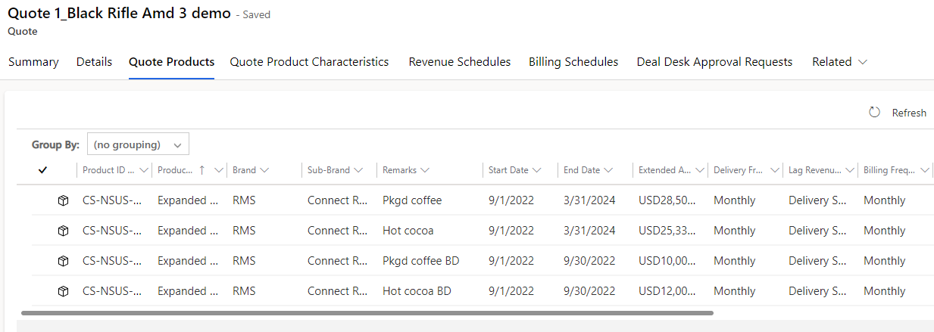

* These are entered as the deltas as Deal Desk is only entering full contracts upon renewal
  + Details by revenue code are needed for billing, gatekeeping (as shown in screenshot)
  + SAP deferred revenue placeholders are needed for forecasting. Deal Desk is not entering placeholders today and will not start adding this.
* In this example, 4 delivery objects would be created; we aligned that was appropriate
* As this does not have the full contract, this will not create a baseline at renewal. That is understood by Deal Desk, and we will continue to support creating baselines in MSD until everything is in there.

## Amendments for contracts where the base LSA **is** in MSD

We used Pre-Brands Amd 1 as an example. OP-000447863 in MSD UAT

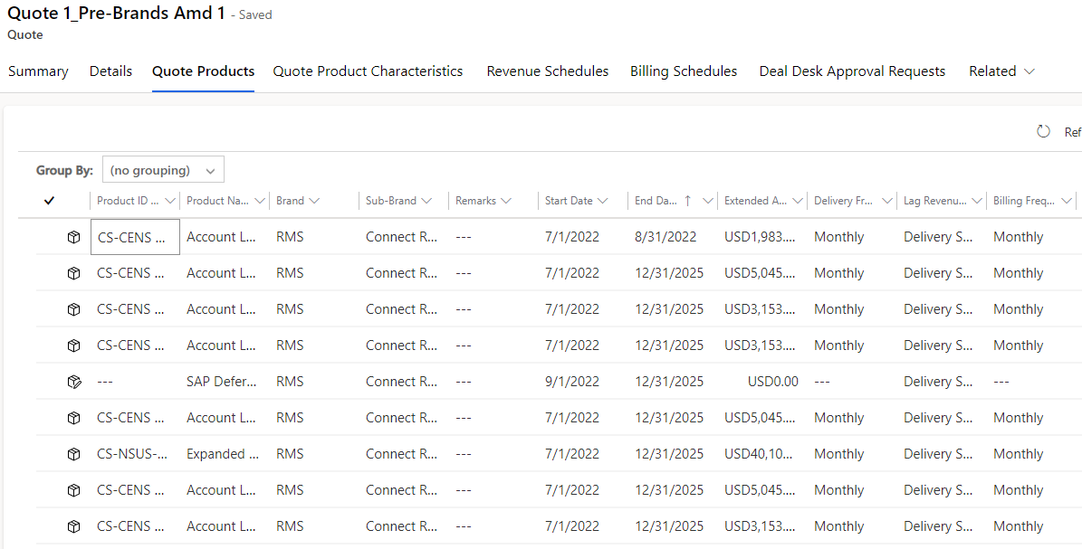

To correctly enter the quote:

* Identify the contract lines which are changing
* Adjust the dates of those contract lines changing. Add lines for new services. For example, service removed as of 9/1 will now have an 8/31 end date. If automated rate card, system will recalculate book price. If manual price entry, user will need to adjust book price.
* Calculate the new cumulative value of the contract and adjust the overall deal price/discount levels and allocations to match this
* For deals that should be billed against a fund, make sure to include a product line inside the quote with the product ID FUND_USG and the value of the charges in negative so, we can ensure proper SAP integration. In case that the fund will be credited a positive amount, please use the product ID FUND_CT. In these cases, the quote should have a 0 value after applying the fund and product lines.
* Add SAP deferred revenue placeholder(s) that represent the delta
* We discussed that this is more work than Deal Desk does today and for an amendment that doesn’t have the base LSA in MSD, but it will provide us with the baseline come renewal

Create New Quote in Existing Opportunity

**Q: How Do I Create a New Quote in an Existing Opportunity**

A: From Opportunity, navigate to the Quotes Tab

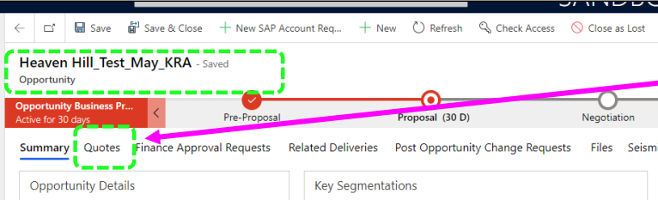

You should be able to see all existing quotes tied to that opportunity, like listed below

To create a new quote, within the same opportunity click the “+New Quote” button located on the right side of the screen

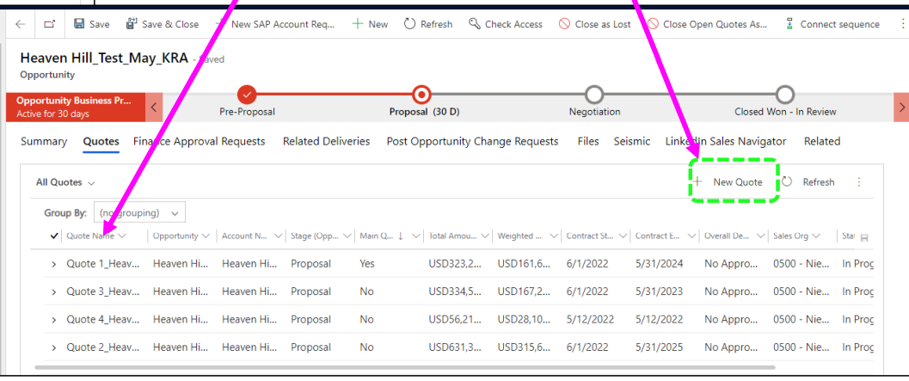

This will then take you to the new quote created:

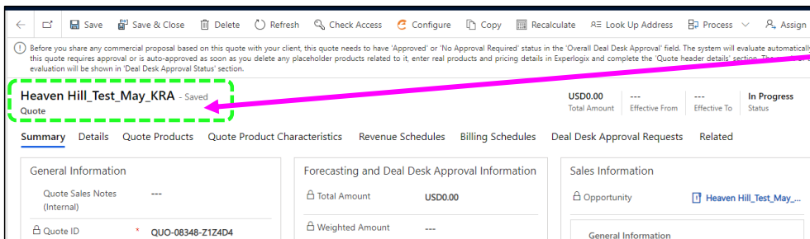

On the Summary tab, you can re-name the quote to whatever you would like. Click “save.”

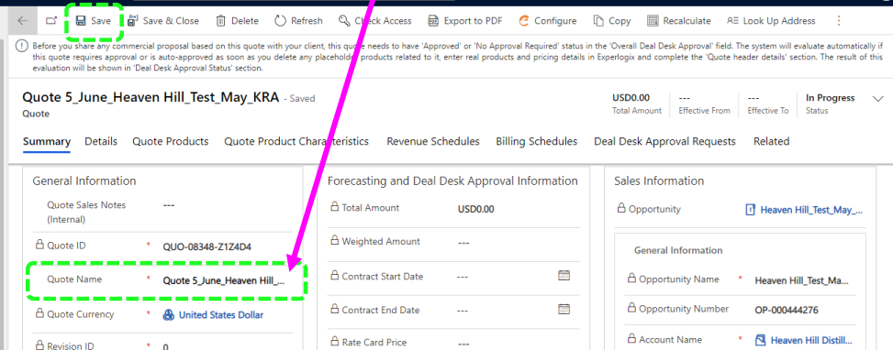

Any subsequently created quote after the very first one created when the opportunity was opened will not be marked as the “main quote.” The main quote should represent the option the client will be moving forward with.

If you need to mark a newly created quote as the “main quote” you will need to migrate back to your opportunity

The quote currently designated as the “main quote” will be shown in the Main Quote’s Forecasting information, located in the center of the screen.

From there, you can click on the magnifying glass on the right-hand side of the field, which should return all quotes tied to that opportunity.

To change the main quote, you can simply select the quote from the drop-down list, then hit save

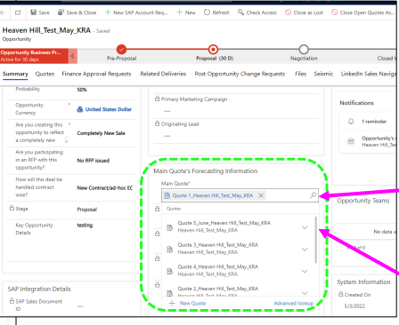

Once your new quote is selected, it should be reflected in the Main Quote field under the Forecasting Information section, then hit “save”

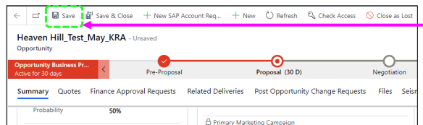

To Validate that was done correctly after saving, if you go back to the quotes tab on your opportunity, you should see the newly made main quote showing a “yes” in the main quote column, whereas all others have a “no.”

If you wish to then finish configuring your new “main quote” you can do so by highlighting the row in question and clicking the black arrow icon on the far right of the line

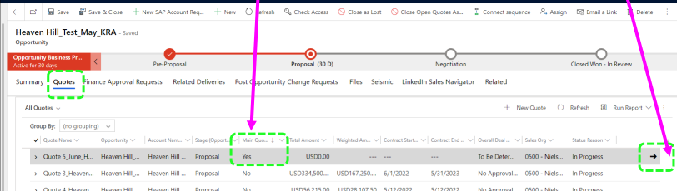

To validate once more that your main quote is your “main quote” you should see a gray checkbox filled in the Main Quote filed on the quote, under General Information

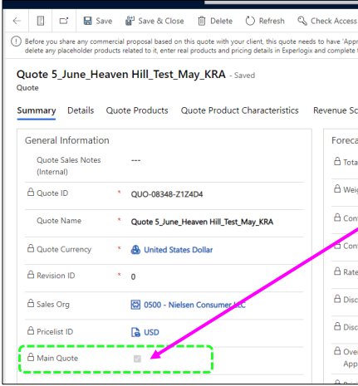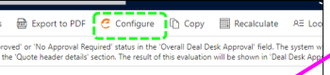

From there, the process remains the same as it would when creating a brand-new quote. by selecting “configure” button from your newly created Quote, a new window will launch, where you’ll click on “Select Products”

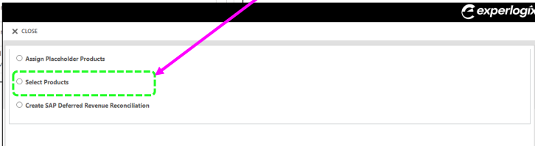

For Periodic Products, you should select 1st day of month as start date, and last day of month as End Date

From the “Manage Defaults” tab, you’ll be able to enter your start/end dates for your contract term, set any defaults related to delivery or billing frequency for the products you’ll be configuring as well as filter products by Brand or also Sub-Brand for results in your Manual Price Entry selections (formerly product picker)

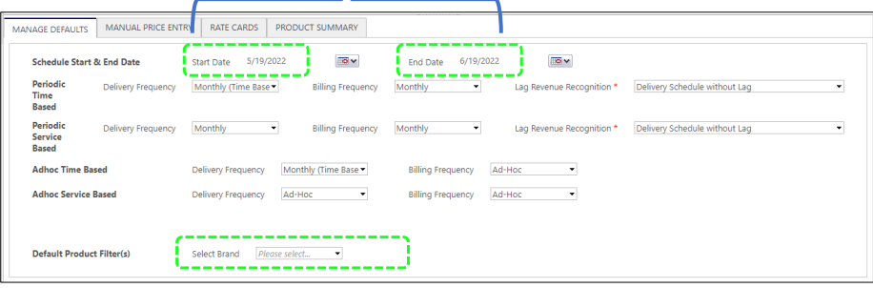

The “Manual Price Entry” tab is where all products would be selected for pricing you’ve either done or been provided with from outside MSD.

Clicking the “Add Product” button will launch a separate window with all products available in your Sales Org. You’re able to filter or search by portions of a product name or code, or page through should you wish to do so. Clicking in the white squares on the left hand of the window will add that product to your selected options. Once all have been selected, clicking the Save button (which will appear to the left of the “Refresh”) will bring you back to the tab, where you will see your selected products listed and can add your charges.

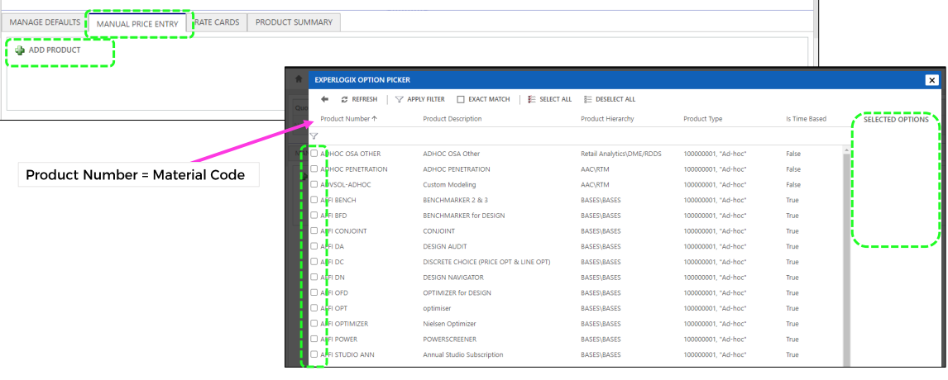

Migrating to the Product Summary Tab will show you all products you have configured in the quote, whether they be from a rate card, or manual price entry

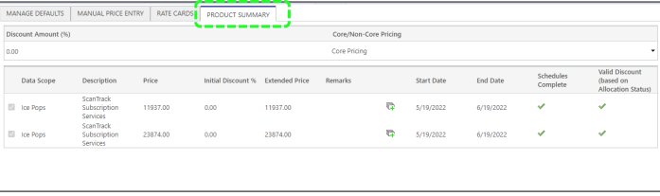

For discount application, there are multiple options – either applying across all products utilizing the “Discount Amount %” field, applying at a line level, utilizing the “Initial Discount%” column, or a combination of both. Should you pass a discounting threshold set for your market, the “Pricing Approval Status” field in the header will change accordingly and you will be notified that approval will be necessary.

Selecting “Save and Close” will save your configuration and write back the details to MSD where you can progress to Deal Desk for approval, if needed.

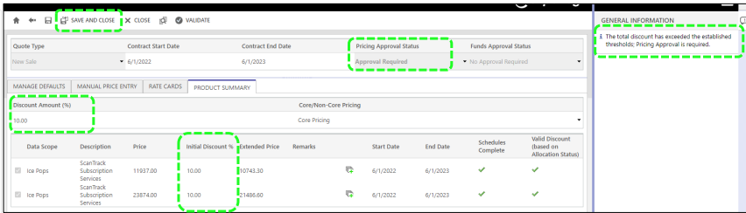

# Editing Product Data for Opportunities Migrated

**Q: Why can't I edit product data for opportunities migrated from Salesforce? Why if I change Est. Close date for a migrated opportunity, part of migrated schedules may get deleted and therefore drive not accurate forecast?**

**A:** Product input is done in Experlogix which is a separate platform connected to MS Dynamics. Experlogix didn't exist in Salesforce, therefore, any migrated data is not connected from Experlogix and can't be updated from Experlogix. Also, for periodic products we do have an automation to move revenue schedules preceding the Est. Close date to the Est Close date for more accurate forecast. This automation doesn't work correctly with products not linked to Experlogix.

*In case you want to edit product & pricing details or Est. Close Date for migrated opportunities, you need to establish their connection to Experlogix first as per the following guidelines:*

You need to change product & pricing details (e.g. start date, end date, amount, billing frequency, delivery frequency) or Est. Close Date on a migrated opportunity => please create a new quote for your migrated opportunity, mark it as the main quote and configure this new main quote in Experlogix by adding product & pricing details from scratch. Change Est. Close date as needed after that

In MS Dynamics you used the “manage existing contract” functionality on an opportunity migrated from Salesforce => if case the original migrated opportunity didn’t have connection to Experlogix established as per the step described above, the opportunity created via “manage existing contract” functionality will not have it either; in this case you need to create a new quote for the opportunity created via “existing contract management” action, mark it as the main one and configure it in Experlogix by adding product & pricing details from scratch

No change needed for a migrated opportunity or needed changes do not relate to product & pricing details or Est.Close date -> You can use and edit migrated opportunity w/o performing the above described steps. Example: Bill To Party or Sales Group can be changed on migrated opportunities w/o establishing connection to Experlogix

# Revenue Walk

**Q: How do I fill out the revenue walk section of my opportunity?**

**A:** The revenue walk is required for all opportunities that are Managing Existing Contracts and Renewal or Yearly Update. It is required to move from Negotiating stage to Closed/Won. Once the opportunity is moved to Closed/Won, these fields can no longer be edited. The Deal Desk analysis includes the inputs for the revenue walk for each option, at the top of the “Mgmt Summary” tab. Be sure to enter the inputs corresponding to your opportunity’s main quote.

# Closing an Opportunity as Lost

* Before you can close your opportunity as lost, there are a couple items you must look at first:
  + Does your opportunity have any open quotes? If yes, you must close them first
  + Once you close the quote, if you go under Quotes, you can see the Quote Status Reason Is Lost
  + The Quote will now be Read Only

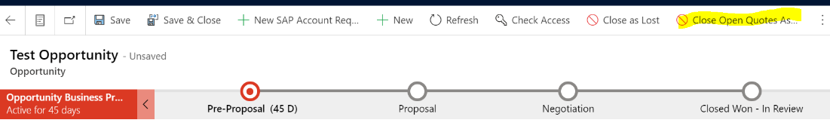

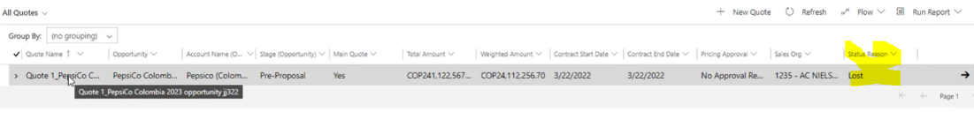

* In addition, if there are any pending gatekeeper requests open, you must recall them

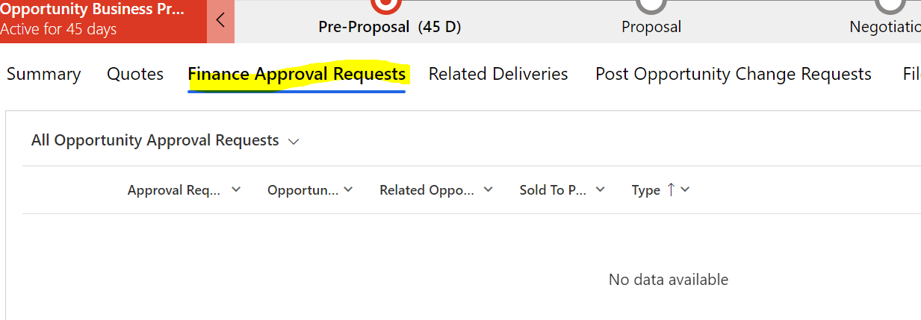

* Now you can Close as Lost the Opportunity

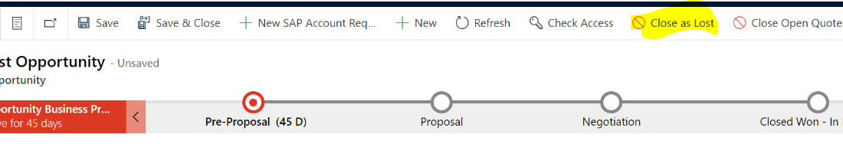

* You need to complete the required information
  + Status Reason: Choose the most appropriate reason
  + Actual Revenue: the amount of opportunity
  + Close Date: defaults to today
  + Competitor: we should use this if we lose to the competition
  + Description: enter any additional details

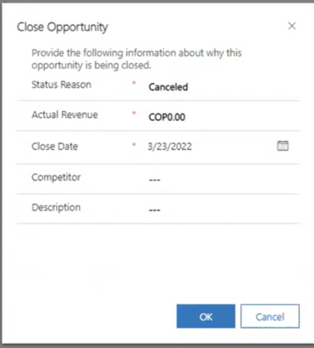

* Opportunity is now in Read on in a gray bar at the top – and marked as Lost
* Last Opportunity stage is kept where it was lost at

# Rate Cards

**Q: How do I add prices for services not included in automated rate cards?**

A: Use Manual Price Entry tab in your quote configuration

**Q: My client wants to add a service to an existing database via contract amendment (ex: weekly updates, more UPCs, another geography). Why can’t I get that price through the automated rate cards?**

A: MSD does not currently have the capability to generate only the incremental price for the new service. The technology road map includes features that will enable this in the future. For now, the pricing analysts will determine the book price and add it to the quote via the Manual Price Entry tab.

**Q: Does that mean that in a renewal, I cannot change the database specs?**

A: No. The limitations mentioned above are for incremental services sold in during the contract term and contracted via amendment. For a renewal, database specs can differ between options.

# Renewal Process

**Q: Will we still build a baseline / Option 0 for renewals?**

**A**: Yes, the Deal Desk team will still build a baseline, aka Current. This will now be a quote on the renewal opportunity. See process maps for more details.

**Q: Will we still have Deal Strategy Review (DSR) meetings?**

**A:** Yes, large deals and deals with significant discounts / price compression will still utilize the DSR meeting for review & approval. The approval will be documented on the MSD quote.

**Q: We’ve been working on renewal for a while and have several proposal options approved as CRB Summaries. How do we move to MSD?**

**A:** Working on renewal deals within MSD is advantageous to Deal Desk, Account Development and Renewals teams, so we’d like to work on as many deals directly in MSD as possible. But we know that for deals started before MSD launched, it will be easier to finish in the old CRB Summary process. For these deals, we will continue to create options via Excel until the final proposal. Once the proposal is finalized,

Deal Desk will create a quote corresponding to the final option and approval will be documented in MSD. That will help you have an accurate forecast for this renewal and set you up for accurate amendment opportunities in the future.

# Discounting & Approvals

**Q: I know I want my proposed price to be $x. How can I get it to exactly that number?**

A: As of the launch of MSD in May, you cannot enter a specific total price (this is slated for a future upgrade). You can use this calculator to help figure out the discount percent to enter to get to the specific total price.

**Q: The Quote Header Details Approval field says, “To be determined.” How can I make that update?**

A: First, ensure you have all required Quote Header fields filled out.

If they are all filled out, you can force the system to reevaluate if approval is needed. Change the Number of FTEs field to a different number (say 5), hit save, system will now say Quote Header Details Approval is ‘Approval Required.’ Change the Number of FTEs back to the number you want, hit save, and the Quote Header Details Approval field should now be accurate.

**Q: How do term length & price interact in MSD?**

First, know that the total value of the opportunity should reflect the cumulative value of the contract. For example, a 2-year term with a $1,500 annual price will have a total value of $3,000 in MSD. The revenue scheduling feature will ensure the opportunity is forecast correctly, i.e., it will spread the revenue across the term.

Automated rate cards will provide you with the cumulative price over the term. For example, if the rate card price is $1,500 annually and the start & end date are 24-months apart, the automated rate card will show $3,000 as the (cumulative) price. Using the same rate card example, if the start date is 7/1/22 and the end date is 12/31/23, the automated rate card will provide a (cumulative) price of $2,250 = $1,500 per year / 12 months per year * 18 months term = $125 per month * 18 months. In both cases, the revenue schedule will show $125 per month.

US sales teams will include the annualized price in client proposals. To support this practice, when the US Deal Desk team is asked to provide incremental pricing, we will initially enter it into MSD with a 12-month term. We also recommend the sales team do the same when they are utilizing automated rate cards.

The opportunity owner should then adjust the price to the full value of the opportunity once the term is established. Deal Desk team can help with this as needed. We recommend this is done when the quote moves to the negotiation stage before the contract is drafted.

While term discount and term length are clearly related, within MSD term discount is selected independently from term length. Term discount is selected when configuring a rate card or is manually included in manual price entry. If the proposal will be for a 3-year term, but the sales team need to generate an annual price, they can configure the quote for a 12-month term and pick a 3-year term discount. The quote must be updated later to reflect the full 3-year term.

*Note: Cost of living adjustment (COLA) are excluded from the total value of the contract, per MSD processes.*

**Q: My proposal includes price step ups beyond Cost of Living Adjustment (COLA) & product enhancements. For example, the price for OmniShopper in my deal will be 100 in year 1, 150 in year 2 and 200 in year 3. How do I reflect this in MSD?**

A: Your quote should include multiple lines for that service. Each line will include different start & end dates and the proposed (extended) price for that period.

# **MSD Opportunities/Quotes & COLA/API in US deals**

# Definitions

MSD = Microsoft Dynamics

API = Annual Price Index. Often used when referring to a fixed annual increase

COLA = Cost of Living Adjustment. Often used when referring to a variable annual increase

As US now follows a [COLA-based policy](https://nielsenenterprise.sharepoint.com/sites/USConnectPricing/SitePages/US-COLA.aspx), the rest of this document will refer to COLA. Unless otherwise noted, the content of the document applies to both COLA and API.

MSD & COLA

COLA/API can impact a sales opportunity in multiple ways. This document outlines how this is reflected in MSD for US-based deals in three cases:

- COLA applied in the first year of a renewal

- COLA provisions that apply to years 2+ of a multi-year contract

- Application of COLA percent to invoices for years 2+ of a multi-year agreement

COLA applied in the first year of a renewal

Pricing best practices include applying COLA to the first year of a renewal contract, consistent with how COLA would be applied within the term of the renewal. This is calculated by the Deal Desk team when they prepare the waterfall for the first renewal option. This is included regardless of the term length of the expiring contract or renewal, for example an expiring contract with a 1-year term should have a COLA applied when it is renewed for another 1-year term.

Within MSD, the amount of COLA included in the renewal option is included within the [revenue walk](https://nielsenenterprise.sharepoint.com/:p:/r/sites/USConnectPricing/_layouts/15/Doc.aspx?sourcedoc=%7B20AD70DC-9CE0-4C52-B292-25942FC70A6B%7D&file=Revenue%20Walk%20Info.pptx&action=edit&mobileredirect=true). If this COLA is not achieved in renewal year 1 (i.e., it is waived), the amount of COLA in the revenue walk will be offset by a negative amount in the price field of the revenue walk.

COLA provisions that apply to years 2+ of a multi-year contract

The provisions that apply throughout the term of a multi-year contract are captured in the quote header. To follow current US COLA policy, you would pick:

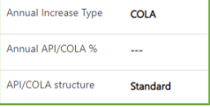

If you are amending a contract that was written to include the fixed 3% API of the old policy, or you have Deal Desk approval to follow the old policy in your renewal, you would pick:

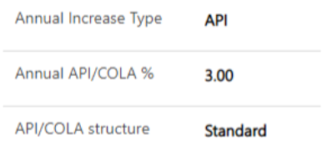

As of August 2022, the MSD system has not yet been updated to include the current US COLA policy in approval rules. When the sales team follows the current policy (box outlined in green), the system will require quote header approval. When this happens, Deal Desk will quickly approve your quote, presuming no other terms or discounts need to be reviewed. The timing for changing the approval rules within MSD is TBD.

Application of COLA percent to the invoices for years 2+ of a multi-year agreement

When entering a quote for a multi-year agreement, COLA is excluded from the total value of the contract, per MSD processes. This applies for both index-based variable COLAs and fixed percent APIs. See [this file](https://nielsenenterprise.sharepoint.com/:w:/r/sites/USConnectPricing/_layouts/15/Doc.aspx?sourcedoc=%7BACC63E7E-AE16-455A-8898-6BF26D4863A7%7D&file=MSD%20Quotes%20%26%20Term%20Length%20(US%20Deal%20Desk).docx&action=default&mobileredirect=true) for more information about term length and MSD quotes.

See MSD Sales Training [module 7](https://nielsenenterprise.sharepoint.com/sites/MicrosoftDynamics/SitePages/Training.aspx), Manage Existing Contract, for information on how COLA amounts are entered into MSD for billing instructions for years 2+. The US is not utilizing this capability for 2022.

# **Deal Desk approval & quote headers**

The US Deal Desk has heard from several members on the AD & Sales teams “My opportunity doesn’t require approval, but MSD says it does, this is holding me back – what's going on?” There are three things that can impact this.

# Approval routing process

Deal Desk cannot approve a quote in MSD until an approval request is routed to us. Click “Initiate Deal Desk Approval” at the top of the Quote. You will not be able to progress your opportunity until this approval is secured, so click that button once the quote is complete even if you are not sure why the system is requiring approval. If needed, Deal Desk can help edit the quote once the approval is routed to us.

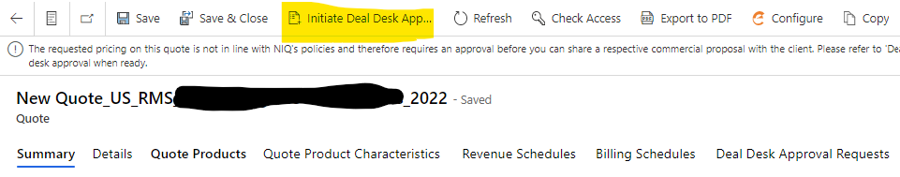

As of Friday 6/3, about half of all NA quotes that are marked as requiring approval have been raised for approval.

# Approval requirements

MSD looks at two things when determining if approval is needed – discount level and quote header fields. While it was a limited number of approvals raised, 80% of approvals in the first two weeks after MSD go-live were quote headers, only 20% were discount approvals.

These are the quote header fields:

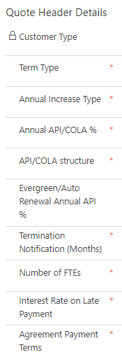

If any quote header field is not within standard terms, Deal Desk approval is required. Here’s an example of a quote that has no discount but has non-standard terms in the quote header:

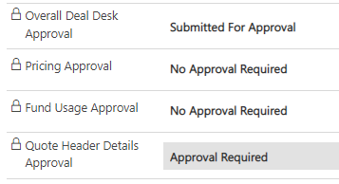

You can hover over the terms to see what the standard is. A full list of non-standard terms that trigger approvals as of 5/23/22 is at the end of this document.

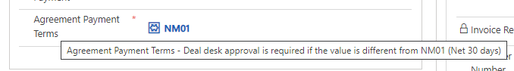

# Standard payment terms

60% of all approval requests in the first two weeks after MSD go-live were payment terms requests. A portion of these payment terms requests will need to continue to be processed as some large clients have non-standard payment terms in their MSAs that need to be carried through on individual opportunities. However, more than one-third of these payment term approvals were changed to standard terms in the DD approval process.

The quote header is displaying SAP codes for payment terms rather than plain English descriptions. Standard net 30-day terms are code **NM01** and standard interest on late payments is **1.5** percent.

# Quote header – When deal desk approval is required

Note: these are the approval rules as of May 23, 2022 (MSD go live). These rules will change as pricing & contracting policies change. Always refer to the hover text in MSD for current rules.

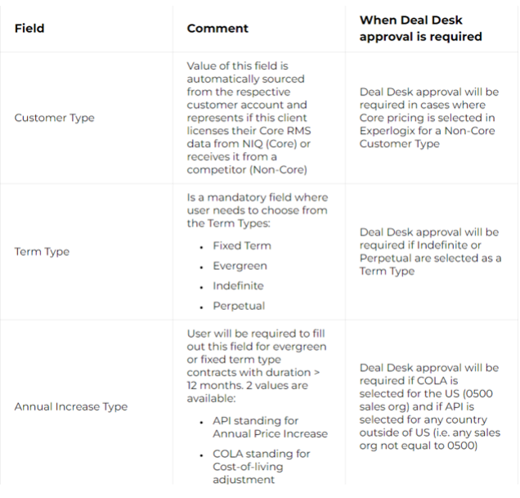

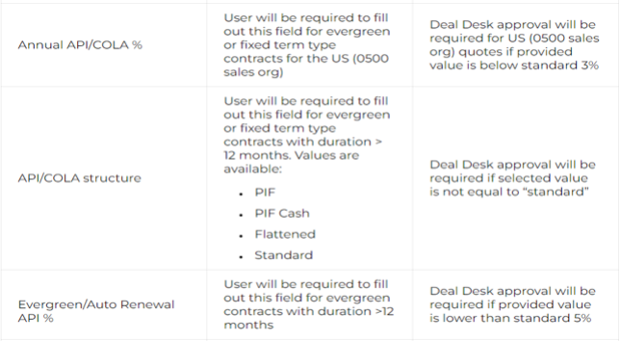

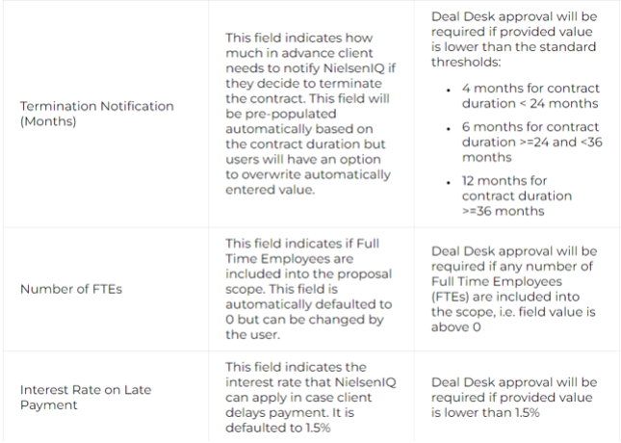

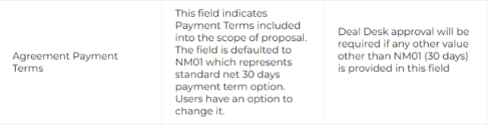

# Requesting Dynamics Help & Support

1. From Dynamics home screen, navigate to the “My activities” section located on left side of page and select “help and support”
2. Once this new page loads, click “+ new H&S request”

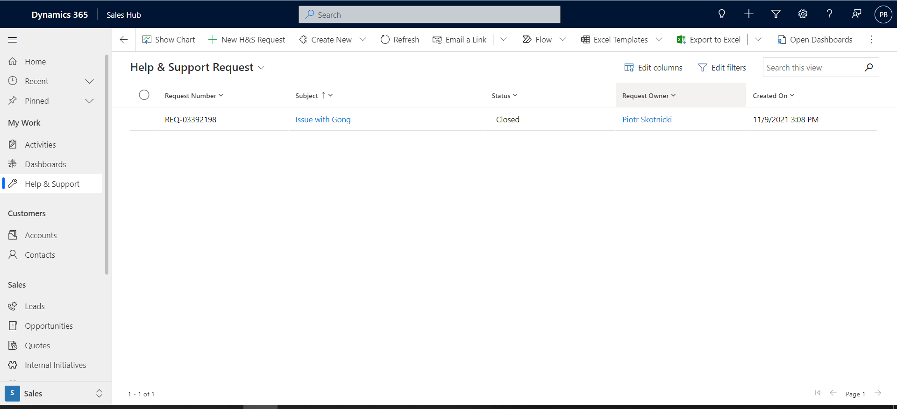

1. Input request details in new window and hit save to complete request
   1. Select Category-Report issue/error; Need Something; Ask question; Submit enhancement idea
   2. Select support area- select the area related to your request so that the appropriate team can handle it.
      1. Customer Success, Marketing, Operations; Pardot/Sales Enablement Tools; Sales/Finance; Experlogix
   3. Add Subject and description details

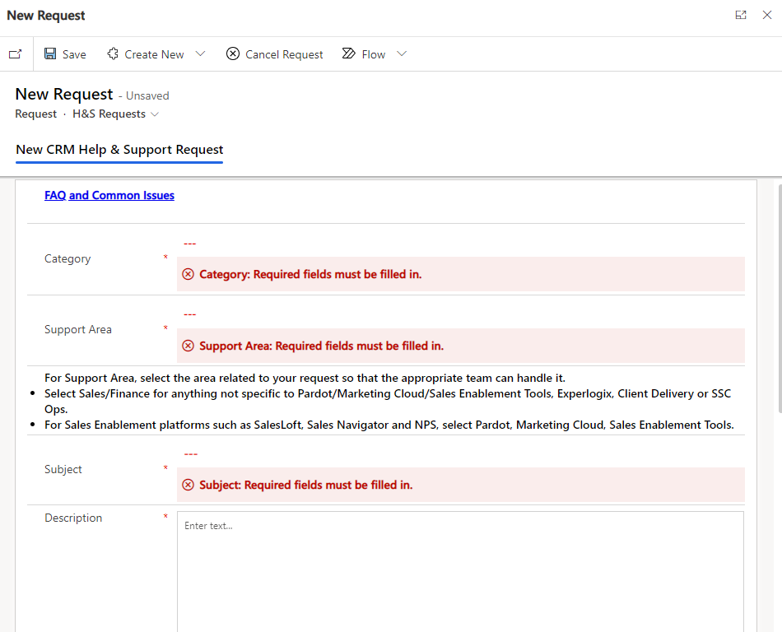

# IMPORTANT LINKS:

[MS Dynamics 365 SharePoint site](https://nielsenenterprise.sharepoint.com/sites/MicrosoftDynamics)

[MS Dynamics 365 Transformation - Sales_Finance Demo Videos - All Documents (sharepoint.com)](https://nielsenenterprise.sharepoint.com/sites/MSDynamics365Transformation/Shared%20Documents/Forms/AllItems.aspx?id=%2Fsites%2FMSDynamics365Transformation%2FShared%20Documents%2FChange%20and%20Training%20Files%2FChange%20and%20Training%20Admin%20Docs%2FStrategies%2C%20Plans%20and%20Decks%2FDynamics%20Dynamos%20Change%20Agent%20Engagement%20Planning%2FUAT%202%20Planning%20and%20Management%2FSales%20Change%20Agent%20Check%2Dins%2FSales%5FFinance%20Demo%20Videos&p=true&ga=1)

[US MSD Deal Desk FAQs.docx (sharepoint.com)](https://nielsenenterprise.sharepoint.com/:w:/r/sites/USConnectPricing/_layouts/15/Doc.aspx?sourcedoc=%7Bd995c8a9-09d7-490e-8353-1d8109011212%7D&action=view&wdAccPdf=0&wdEmbedFS=1&cid=8793d16c-47b1-4dc8-a1e6-96cf084741ef)

[(18) Yammer - Enterprise CRM - Dynamics 365](https://web.yammer.com/main/groups/eyJfdHlwZSI6Ikdyb3VwIiwiaWQiOiI3NzM4NDU0MDE2MCJ9/new)

[Frequently Asked Questions (FAQs) (sharepoint.com)](https://nielsenenterprise.sharepoint.com/sites/MicrosoftDynamics/SitePages/Frequently-Asked-Questions-(FAQs).aspx?source=https%3a//nielsenenterprise.sharepoint.com/sites/MicrosoftDynamics/SitePages/Forms/ByAuthor.aspx)

[Complete Your Training! Dynamics is LIVE! (sharepoint.com)](https://nielsenenterprise.sharepoint.com/sites/MicrosoftDynamics/SitePages/Training.aspx)

[How to EOD](https://nielsenenterprise.sharepoint.com/sites/MicrosoftDynamics/Shared%20Documents/Forms/AllItems.aspx?e=5%3A5585f1dfabf14e658b53b51da513d2a3&at=9&FolderCTID=0x012000B6A67EAFF984C1419A1F20118A1CF52A&id=%2Fsites%2FMicrosoftDynamics%2FShared%20Documents%2FMS%20Dynamics%20Sales%20and%20Finance%20Video%20Demonstrations%2FSales%20%2D%20Delivery%20Date%20change%20and%20EOD%20submission%2Emp4&parent=%2Fsites%2FMicrosoftDynamics%2FShared%20Documents%2FMS%20Dynamics%20Sales%20and%20Finance%20Video%20Demonstrations)

[MS Dynamics 365 Transformation - Closing an Opportunity as Lost-20220323_113315-Meeting Recording.mp4 - All Documents (sharepoint.com)](https://nielsenenterprise.sharepoint.com/sites/MSDynamics365Transformation/Shared%20Documents/Forms/AllItems.aspx?ga=1&id=%2Fsites%2FMSDynamics365Transformation%2FShared%20Documents%2FChange%20and%20Training%20Files%2FChange%20and%20Training%20Admin%20Docs%2FStrategies%2C%20Plans%20and%20Decks%2FDynamics%20Dynamos%20Change%20Agent%20Engagement%20Planning%2FUAT%202%20Planning%20and%20Management%2FSales%20Change%20Agent%20Check%2Dins%2FSales%5FFinance%20Demo%20Videos%2FClosing%20an%20Opportunity%20as%20Lost%2D20220323%5F113315%2DMeeting%20Recording%2Emp4&parent=%2Fsites%2FMSDynamics365Transformation%2FShared%20Documents%2FChange%20and%20Training%20Files%2FChange%20and%20Training%20Admin%20Docs%2FStrategies%2C%20Plans%20and%20Decks%2FDynamics%20Dynamos%20Change%20Agent%20Engagement%20Planning%2FUAT%202%20Planning%20and%20Management%2FSales%20Change%20Agent%20Check%2Dins%2FSales%5FFinance%20Demo%20Videos)

[Quotes & Opportunities In Dynamics Process](https://nielsenenterprise.sharepoint.com/sites/Q2CCPQCLM/Shared%20Documents/Forms/AllItems.aspx?id=%2Fsites%2FQ2CCPQCLM%2FShared%20Documents%2FGeneral%2FRate%20Card%2FCPQ%20Communications%2FCPQ%20in%20MSD%20%2D%20Create%20Quotes%20May%202022%2Epdf&parent=%2Fsites%2FQ2CCPQCLM%2FShared%20Documents%2FGeneral%2FRate%20Card%2FCPQ%20Communications&p=true&ga=1)

[Deal Desk & Pricing Resources](https://nielsenenterprise.sharepoint.com/sites/USConnectPricing/SitePages/Microsoft-Dynamics-&-US-Deal-Desk.aspx)

[New User Request Link](https://forms.office.com/pages/responsepage.aspx?id=9KHHarFfU0G7TxLSAgoffYvI87DE2PpJg1I7FUKLnClUNFEyNlc2QlJPS01KRllWMDBRQTI0ODFFWi4u)

[SAP Request Info Sheet](https://nam02.safelinks.protection.outlook.com/ap/b-59584e83/?url=https%3A%2F%2Fnielsenenterprise.sharepoint.com%2F%3Ab%3A%2Fs%2FSalesEnablement%2FERDiHLQWHf1CpSDUyibIpwIBHUwVDsm1D5dl_e461pL3Gg%3Fe%3DCfjmNp&data=05%7C01%7CKaitlyn.mills%40nielseniq.com%7C261d570e733d4c64895208da6f21973b%7C6ac7a1f45fb14153bb4f12d2020a1f7d%7C0%7C0%7C637944487305398154%7CUnknown%7CTWFpbGZsb3d8eyJWIjoiMC4wLjAwMDAiLCJQIjoiV2luMzIiLCJBTiI6Ik1haWwiLCJXVCI6Mn0%3D%7C3000%7C%7C%7C&sdata=gvjyB9HScJnmoXfBYWFwvBxZVHy8j52YHkhnWZ4dQ6g%3D&reserved=0)

[Quote Configuration Tips.docx](https://nielsenenterprise.sharepoint.com/:w:/r/sites/SalesEnablement/Shared%20Documents/Post%20Sales%20Enablement/Dynamics/Quote%20Configuration%20Tips.docx?d=w125a0a6a4d4244748903e0e7b9960382&csf=1&web=1&e=xGd8Yc)

[Fund Usage in MSD Process Outline 3.13.23.docx](https://nielsenenterprise.sharepoint.com/sites/USConnectPricing/_layouts/15/Doc.aspx?sourcedoc=%7B3FDE08B9-12E8-44B0-968A-7C51BB8673AC%7D&file=Fund%20Usage%20in%20MSD%20Process%20Outline%203.13.23.docx&action=default&mobileredirect=true)